Welcome Optimists Worldwide Program
Recruiting new members is not a once a year event but is an ongoing process. Every event, activity and fundraiser is an opportunity to bring in new members and should be treated as such. Volunteering and membership has changed and expanded through the years. Below are some of the current trends:
- When people are looking for volunteer opportunities, they are looking for group activities which will allow them to interact with people they not otherwise meet.
- When we look at professional who volunteer, they comes with a set of skills that can be very useful to an organization. These professionals are often looking to involve something different from their work life.
- Volunteers want flexibility to give of their time and talents in ways that fit in with their life and family.
- Many volunteers are looking for short-term opportunities and the challenge is to satisfy this desire while satisfying our need for members.
- Volunteers come with their own set of goals, Optimist Clubs need to allow potential members to articulate their goals and then work to achieve them together.
In addition, there are 3 types of volunteering that Optimist Clubs need to be aware of:
- Skills-based – where volunteers share their time based on their skills and talents and how they can have an impact on the organization.
- Employer-Supported – as employers become more global citizens they encourage and in some cases require their employees to volunteer. In some instances, they may choose the cause or organization they are going to volunteer with. In other instances, an employer may allow their employees to select where they want to volunteer but expect a certain commitment in terms of hours.
- Family – people may choose to volunteer with organizations where their parents volunteered because of a sense of familiarity and duty. In addition, families will choose activities where the whole family can participate together, teaching the children the importance of volunteering and giving back to the community.
This document will give clubs guidance on running events specifically designed to recruit new members and revitalize and re-engage your existing members as well as how to turn every event into a recruitment opportunity.
Social W.O.W. Events
At our core, we are social clubs, we join to help our communities but equally important is meeting new people and making new friends through social interactions. By hosting regular W.O.W. events we can not only recruit new members, but we can revitalize and re-engage your existing membership.
- Decide with your club when you want to hold a social event, this should be on a regular schedule. For example, on months with a fifth week you can hold an event in that fifth week, maybe you decide to pick on day a month to have a social event. Whenever possible it should be on the same day of the week to create consistency.
- Assign a chair and a committee to be responsible for determining and organizing the activities as well as the invitations.
- Set up a social media event (FaceBook, Instagram etc) where you can invite people to attend and you can post information about the events.
- Ask your members to invite their friends to the events or to provide the chair with the email addresses of potential members for them to invite them.
- Prepare a 5-10 minute presentation on your club. In addition, you can have a pictorial presentation running on a laptop during the event for people to stop and look at. Make sure you have membership applications and brochures available through the event.
- If holding the event virtually, set up the platform (zoom, etc) and make sure all invitees have the link to access it.
- In holding the event in person, make sure everything is setup and all invitees know when and where to go.
- Ask at the end of the event, if you have anyone interested in joining the club right now.
- Follow up with all potential members to invite them to attend other events so they can continue to learn more about your club.
Examples of Virtual Events
- Interactive games: Bingo, Trivia, Name that Tune, Scavenger Hunt
- Creative Activities: Paint Night, Baking or Cooking Together
- Interactive Speakers: Internet Safety, A Group you support
Examples of In Person Events:
- Interactive Games: Board Game Night, Minute to Win It, Scavenger Hunts, Trivia, Name That Tune, Bowling, Laser Tag
- Community Service: Packing back packs, Packing healthy foods, Bottle drive, Food drive
- Optimist Programs: Tri Star Sports, Youth Appreciation, Oratorical
- Leisure Activities: Ice Skating, Car Shows, Baseball, Golf, Coffee, Grab and Go Meals

Turning Every Event into a Recruiting Opportunity
- Create a pictorial presentation that shows the activities and events that your club runs. Have this presentation running on a loop so that anyone at the event can stop and watch it.
- Create a presentation board with pictures and information about your club. Information like dues, governance, activities that you run and how to become a member. Make sure to have membership applications and brochures. Make sure you have a member by the table who will interact with people and welcome their questions.
- At every event take 5 – 10 minutes to explain who the Optimist Club is and that you always welcome membership who want to help in the community and make new friends, having fun while doing that.
Social Activity for all ages Example
- The Optimist Club of XYZ has decided to hold a monthly trivia night on the 3rd Friday at 7 p.m. Since right now we are not able to have events in person they are going to start with a virtual event.
- Bobby has been assigned to be the chair and she has been given a committee of 5 members to help her come up with the trivia, invite people and run the event.
- XYZ has a Facebook page and is going to create a Facebook event so that people can be invited and they can posted teasers and information
Facebook Event Instructions
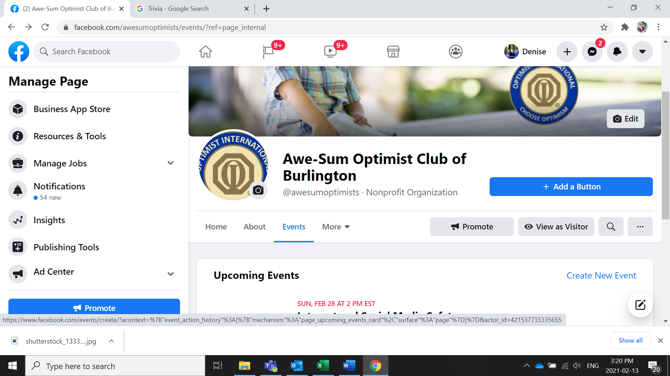
On your Facebook page, Go to your events Tab and select Create New Event

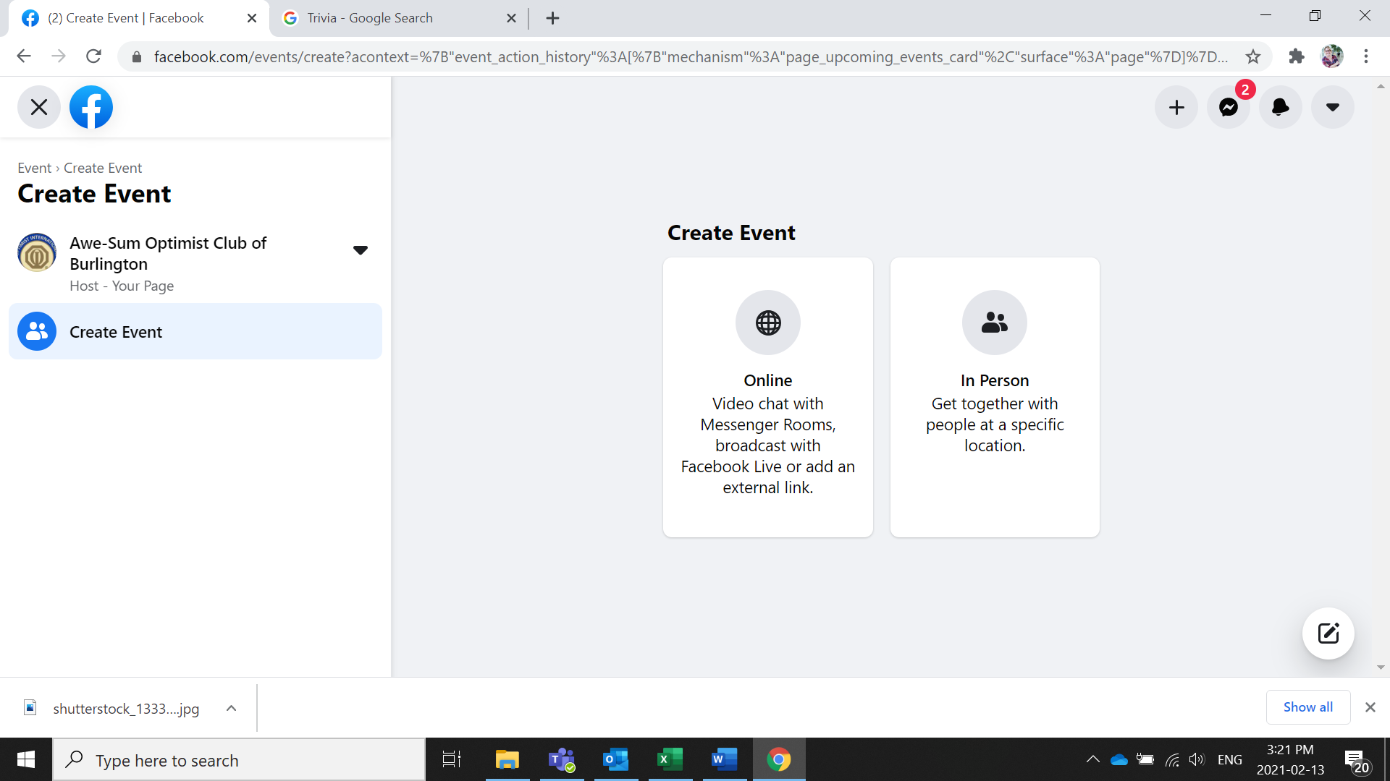
Select Online or In Person

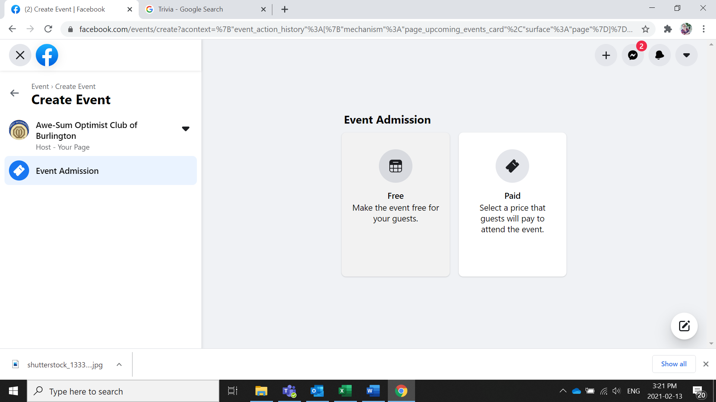
Select whether it is a free event or if there is a cost for it

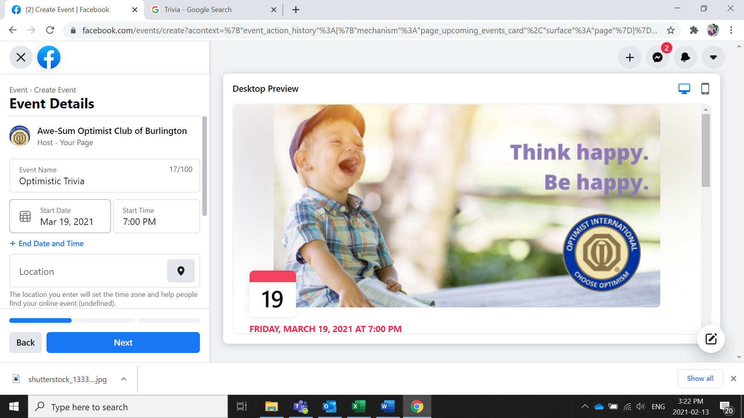
Enter your event details

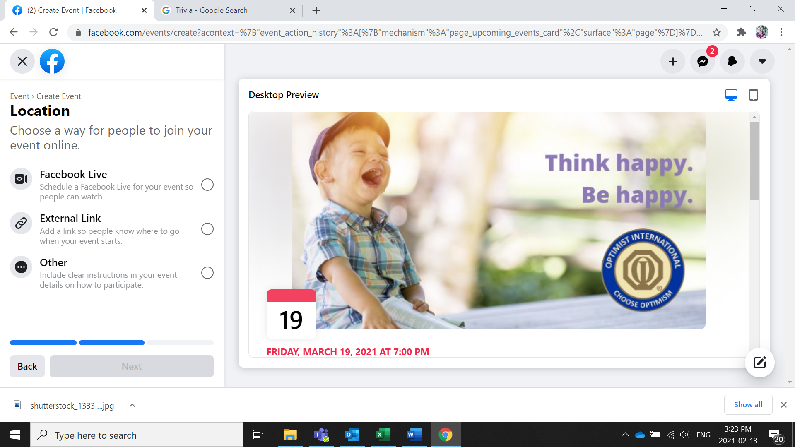
Select how, if you are using zoom select External link or other

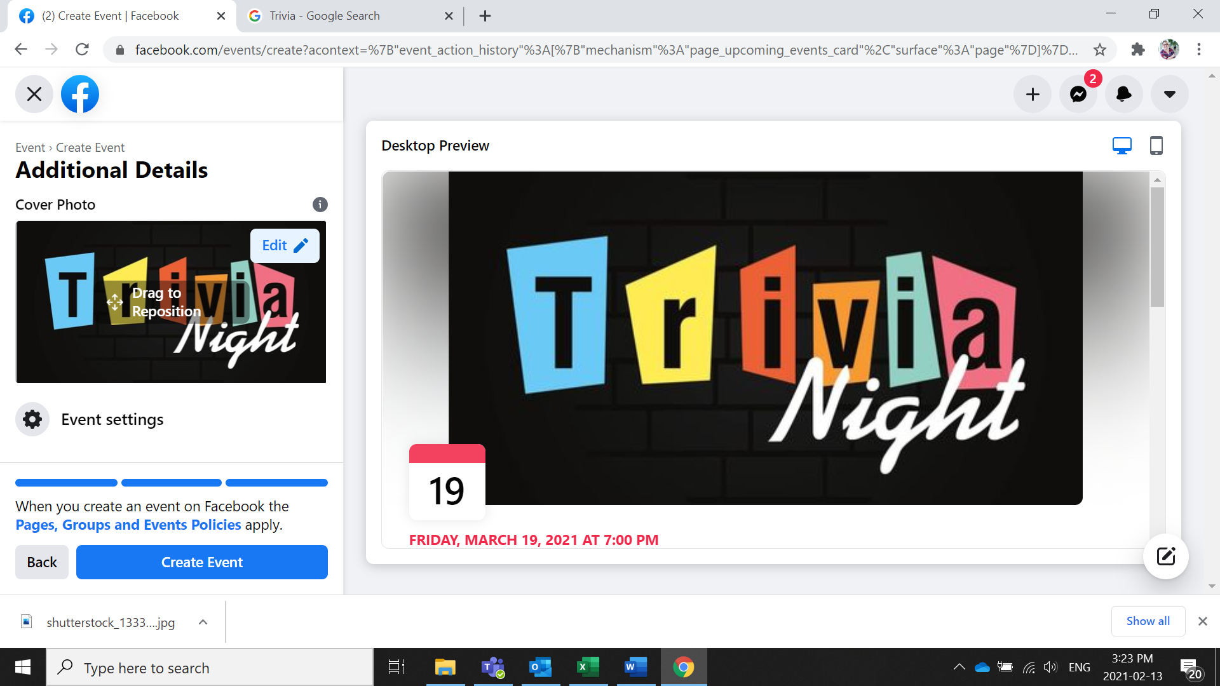
Change your Facebook Cover and create your event
- Now XYZ members can invite their friends to attend the event and Bobby can share information about the event on Facebook.
- Bobby and her team will not set up their virtual platform. They have decided to use Zoom as it gives them the most flexibility. They are going to set it up so that people must register so they will know who is planning to attend and have their contact information.
- Bobby and her team are now putting together the trivia questions and the format for the trivia.
- Bobby has assigned one of her team members to send emails to all their existing members and to all invitees.

Dear Existing Member (use their name),
We are so excited to announce that we will be hosting a monthly trivia night on the 3rd Friday of the month with the first one being held on Friday March 19th. This is an amazing opportunity to reconnect with your fellow optimists, meet new potential members and enjoy an evening out.
We have created a Facebook event which you can find on our Facebook page. We encourage you to invite your friends, the more the merrier. This is going to start as a virtual event using Zoom, the link to register can be found here. When we are able to meet in person we will be moving this to an in person event. We can’t wait to be able to meet together and celebrate our optimism.
If you have any questions please let me know. We look forward to seeing you in March!
Bobby,
WOW Event Chair

Dear Potential New Member (use their name),
We are so excited to invite you to our first monthly trivia night being help on Friday March 19th. With the current restrictions in place we are hosting this first event on zoom. You can find the link here to register to attend. Once we are able to begin meeting in person we will be hosting this event monthly on the 3rd Friday of the month.
We invite you to join us for a fun evening and to learn more about our Optimist Club. The Optimist Club of XYZ has been serving our community for over 40 years with the mission of Bringing Out the Best in Youth, Our Communities and Ourselves. We sponsor sports teams and host scholarship opportunities like the oratorical contest. All of these activities are organized and conducted by our members and volunteers. We hope you will join on the 19th.
If you have any questions please let me know. We look forward to seeing you in March!

Bobby
Optimist Club of XYZ.
- Prior to the event Bobby asks James, one of their newest members to explain why their joined the club and how it has enriched their lives. Bobby will also spend 5 minutes explaining a little bit about the club and the important work they do in the community.
- At the end of the event Bobby asks if anyone is interested in joining. There are 3 attendees who tell Bobby they are interested in joining and Bobby emails them a new member application for them to fill out and send back to her.
- After the event Bobby and her team follow up with all the potential members who attended and invite them to their next club meeting and their next trivia night. Bobby and her team keep in touch with these members and even if they don’t join continue to invite them to events and activities.
Creating an Online Application Using Microsoft Forms
- Go to forms.office.com
- If you have a Microsoft account Sign into your account, otherwise create one
- Select New Form
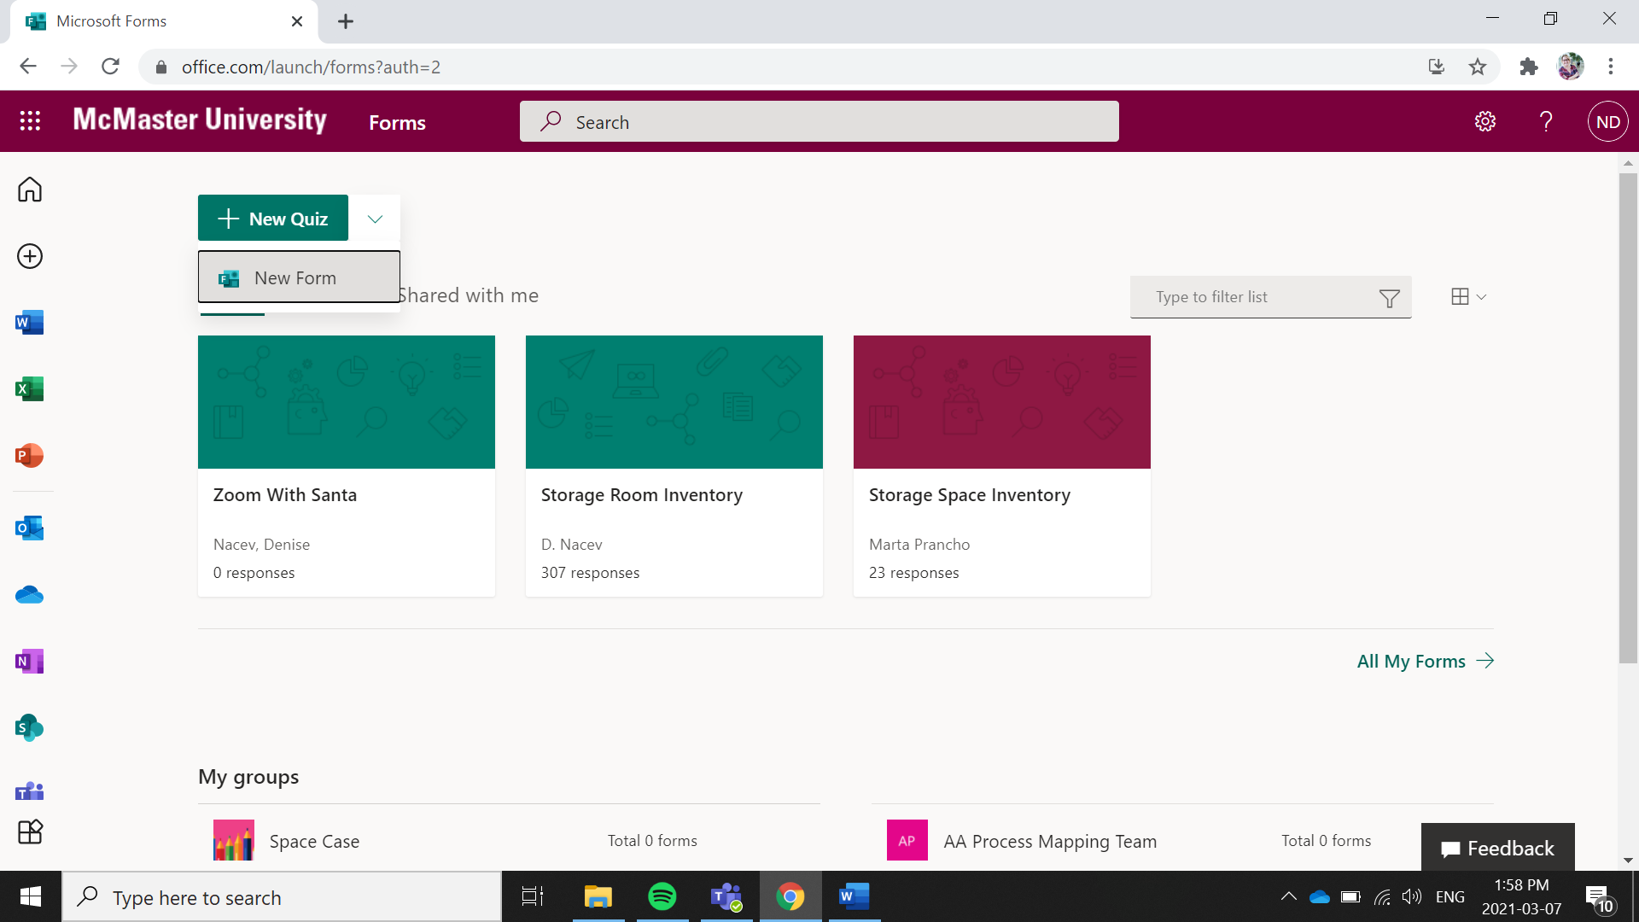

- Give your Form a Title
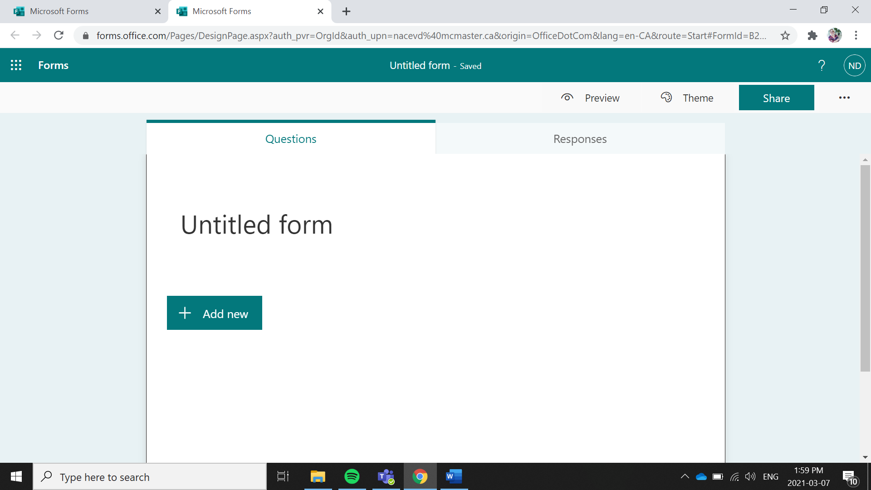
- You can add you club logo by select add image
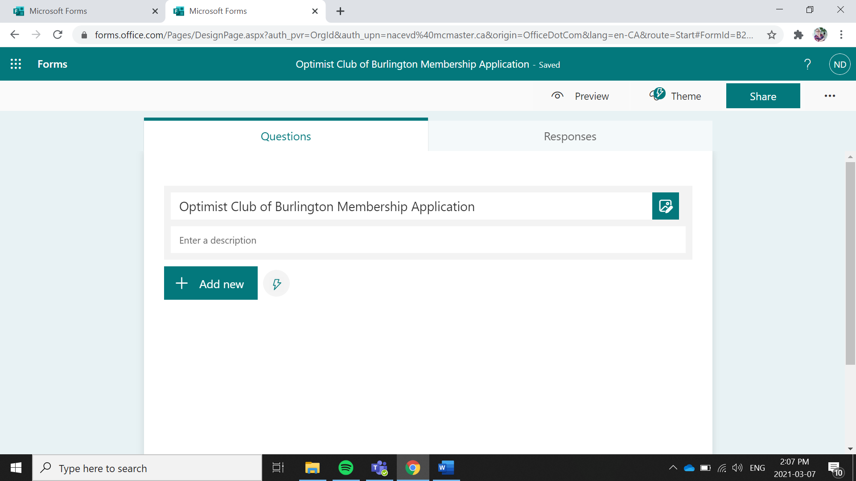

- Start to Add questions by Selecting Add New

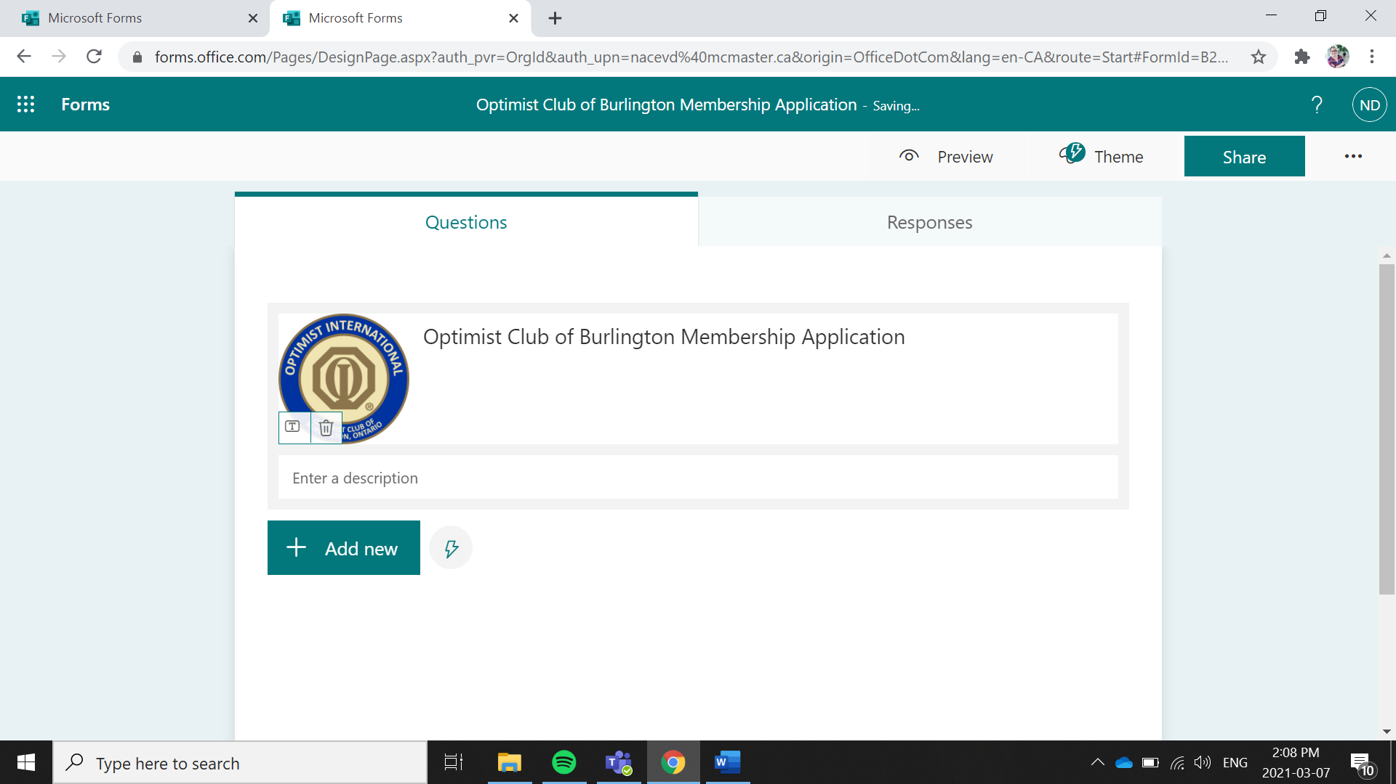
- You can select the type of question you would like
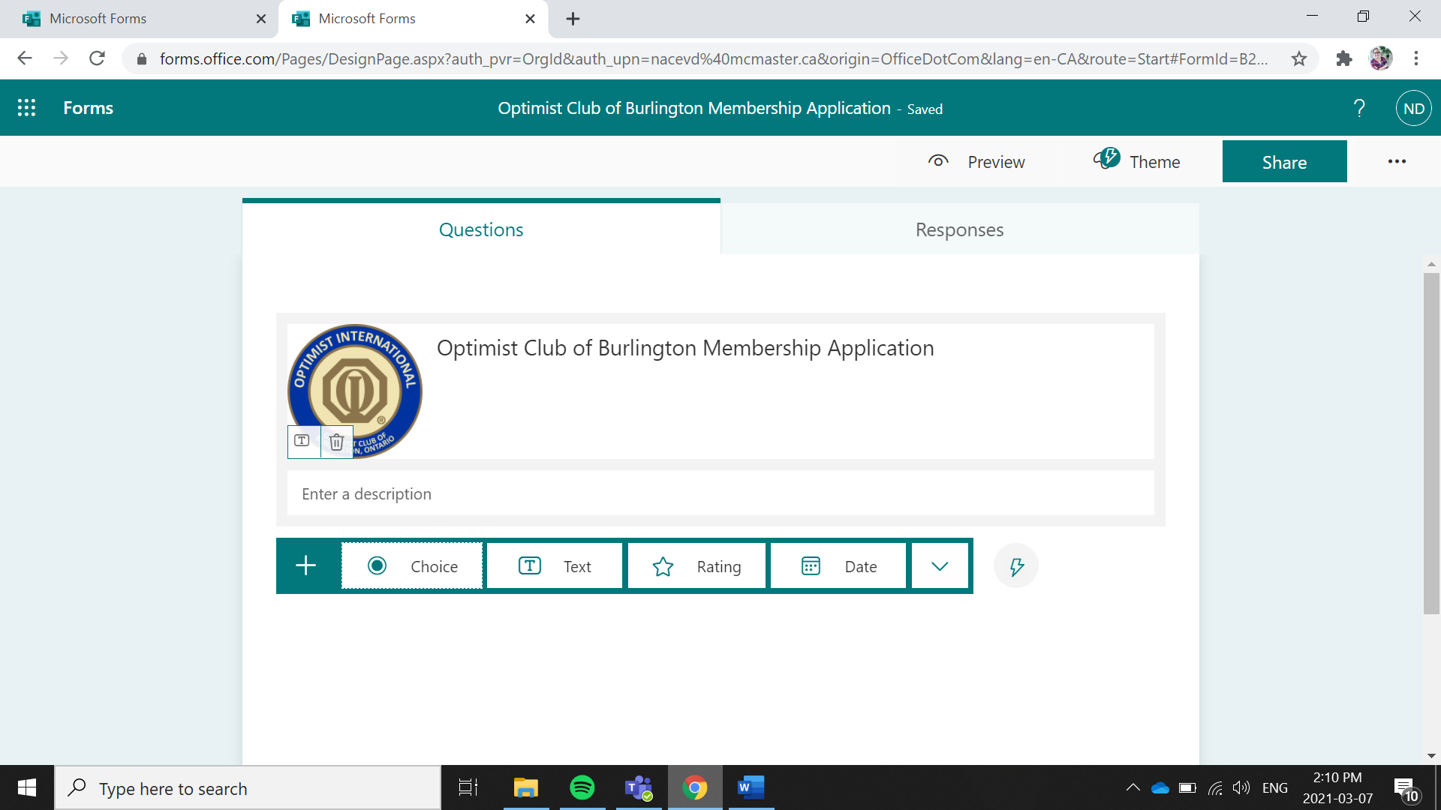
Multiple Choice Free Form Text
- To Enter Name and Contact information select Text. To get Question suggestions select the lighting bolt. This will bring up some commonly asked questions to quickly populate the form
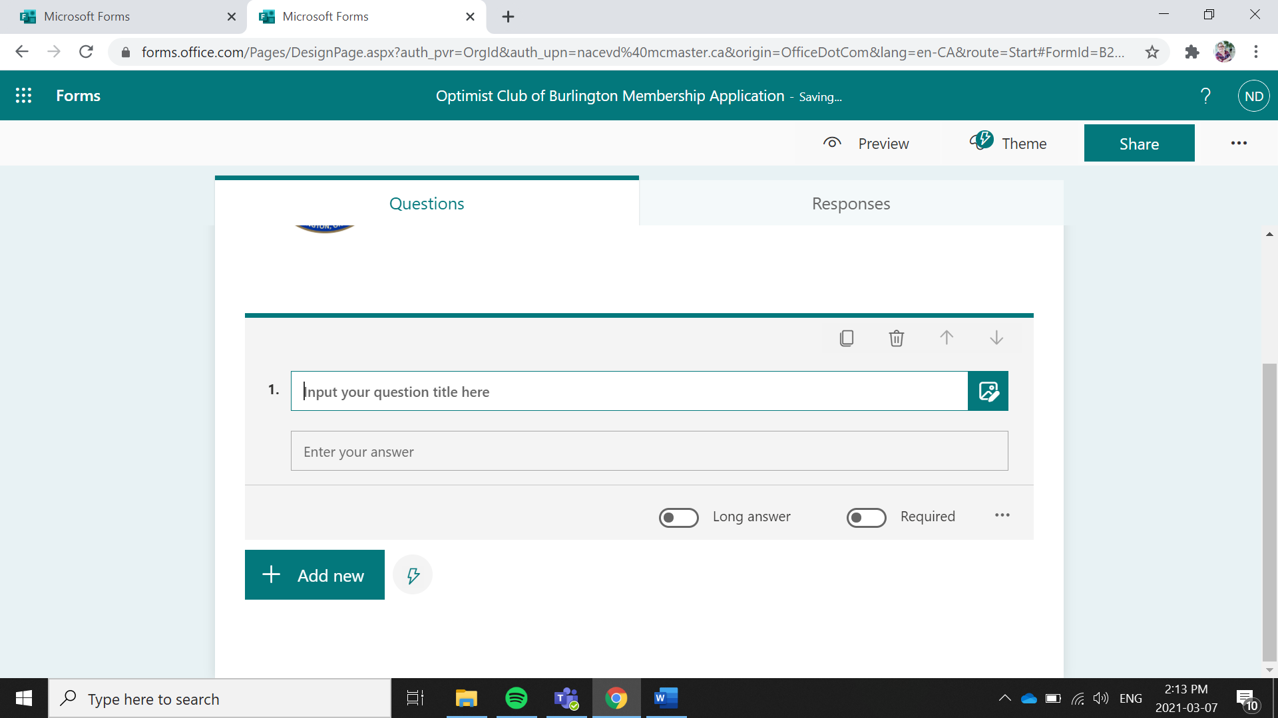
- Select the questions you want to enter into your form. Continue to add the Address Questions into your form.
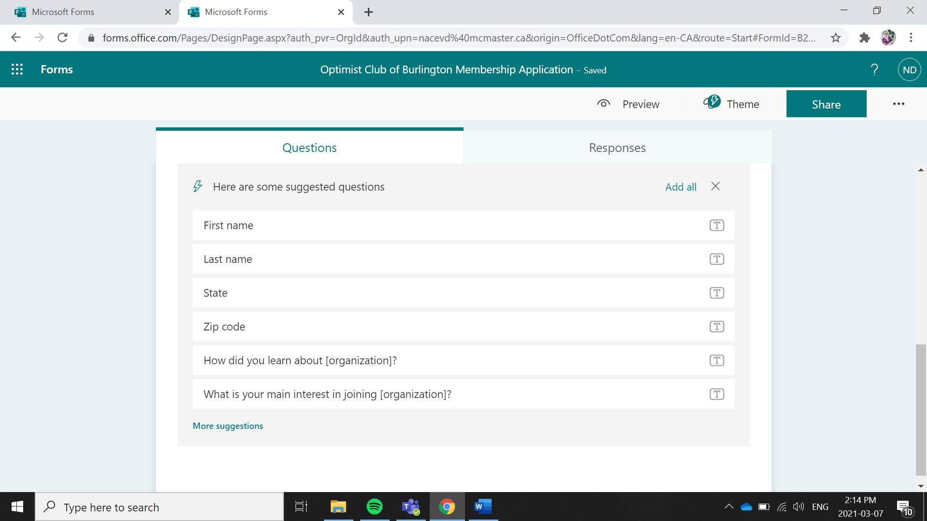

- You can add any other questions you would like your new member to answer
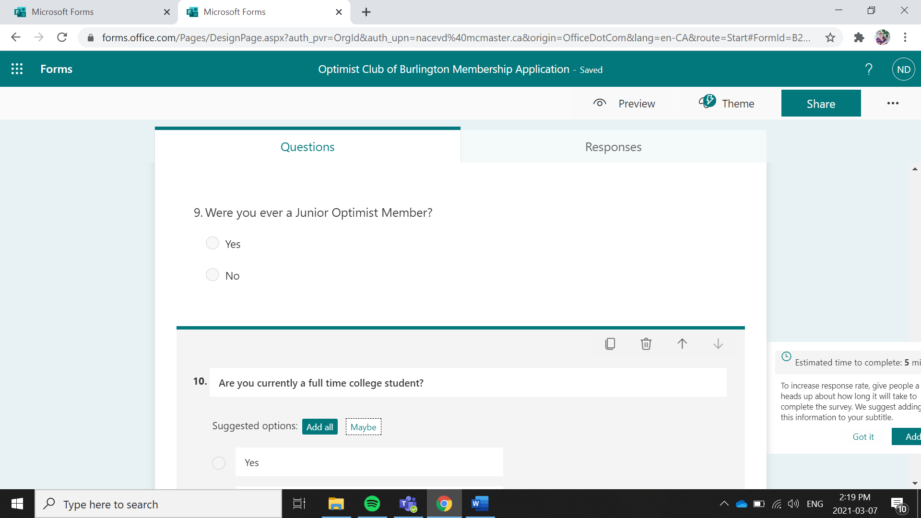
- To add the Member Interest Finder Select Choice from the Type of Questions
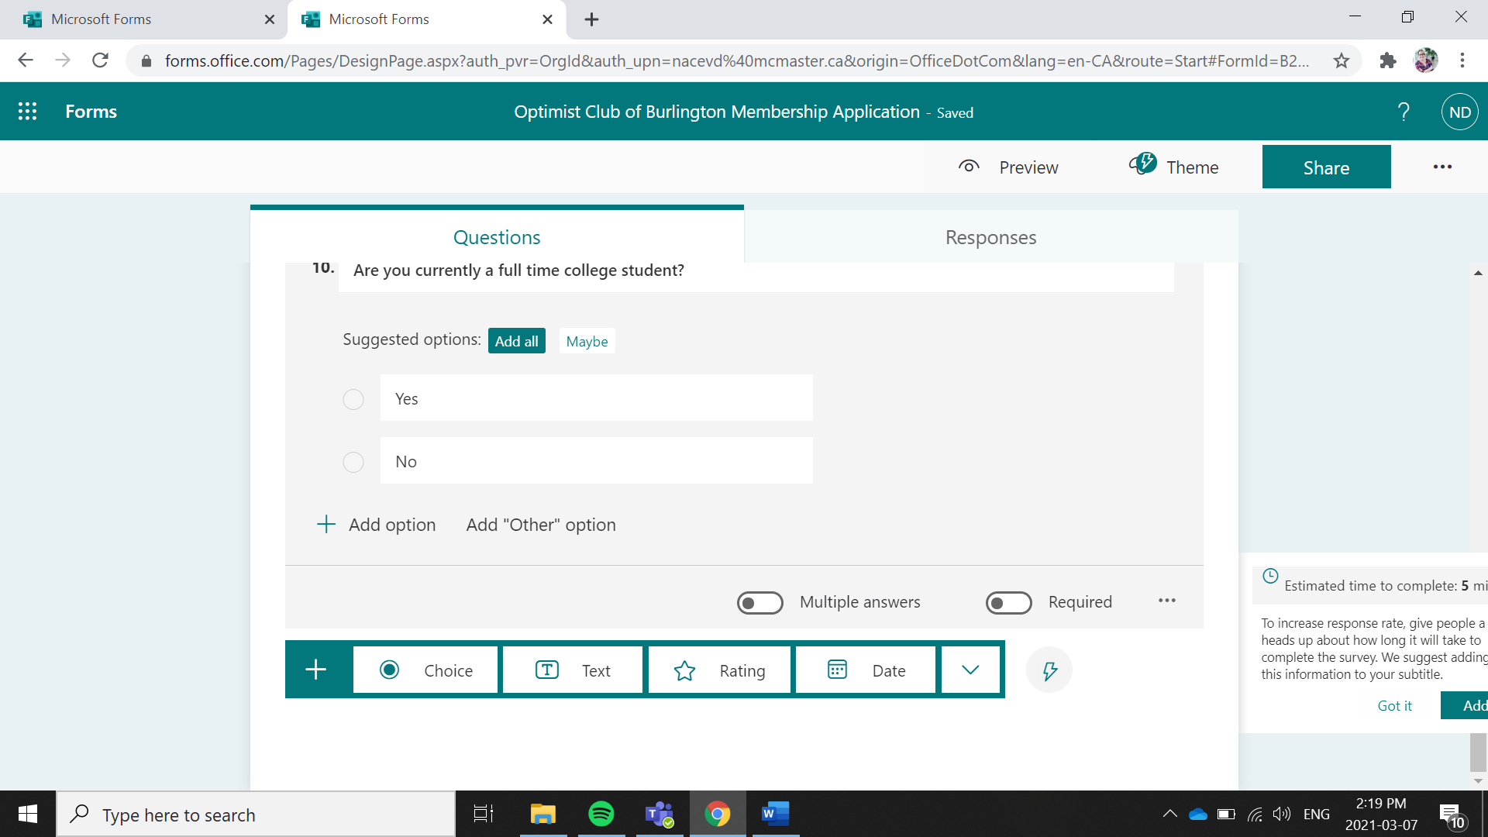

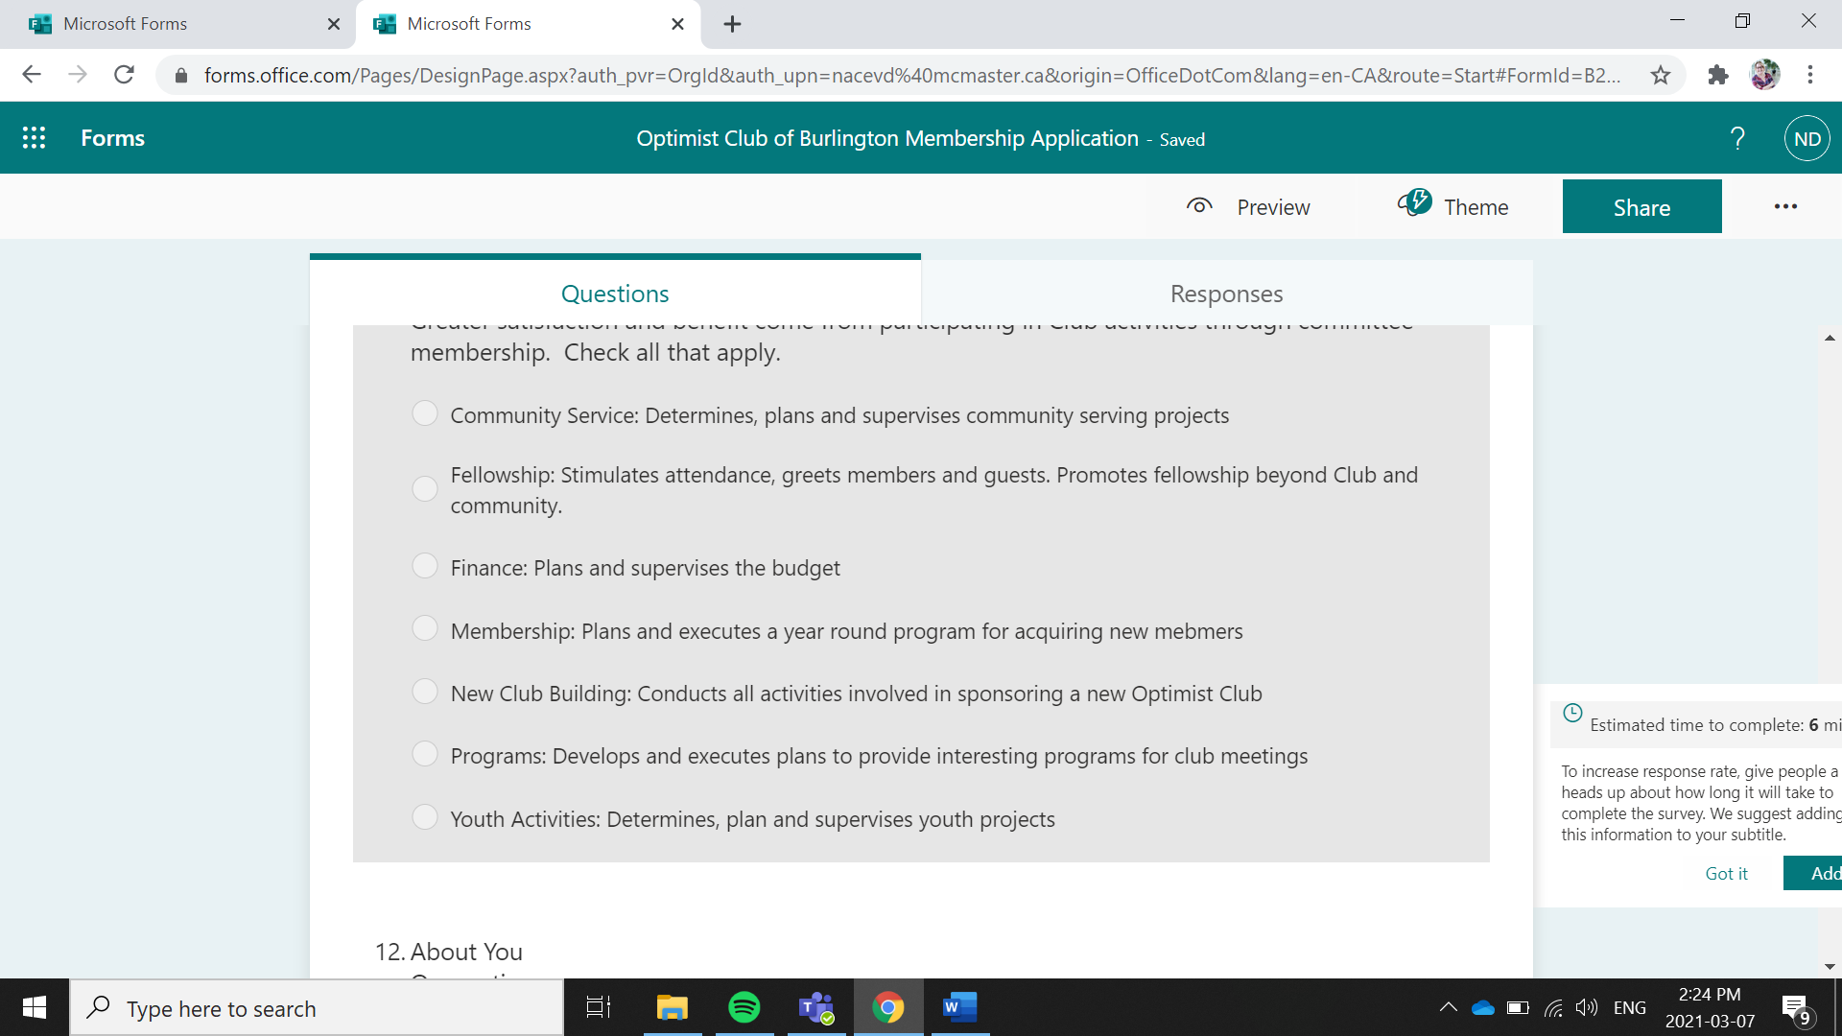
- Once complete you can preview your form
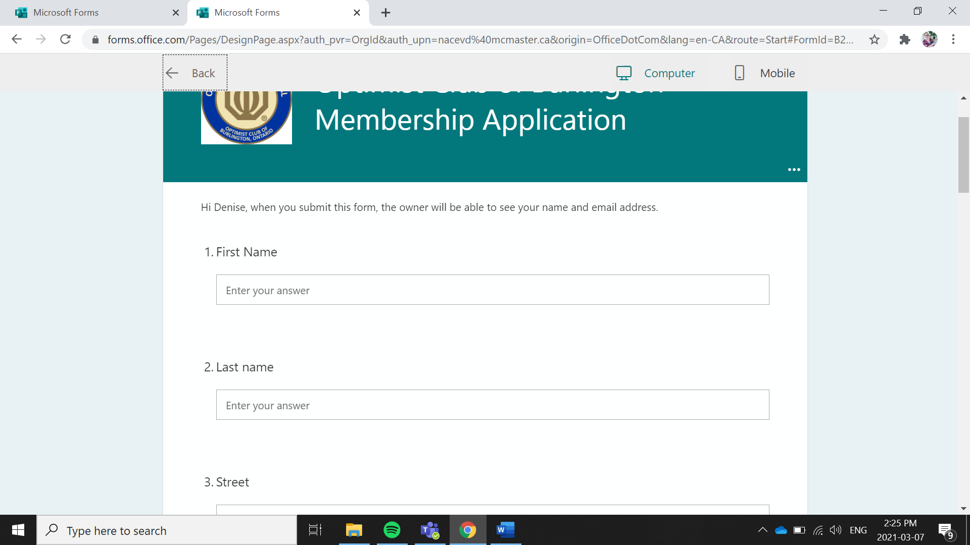

- You will see the responses in the Response Tab
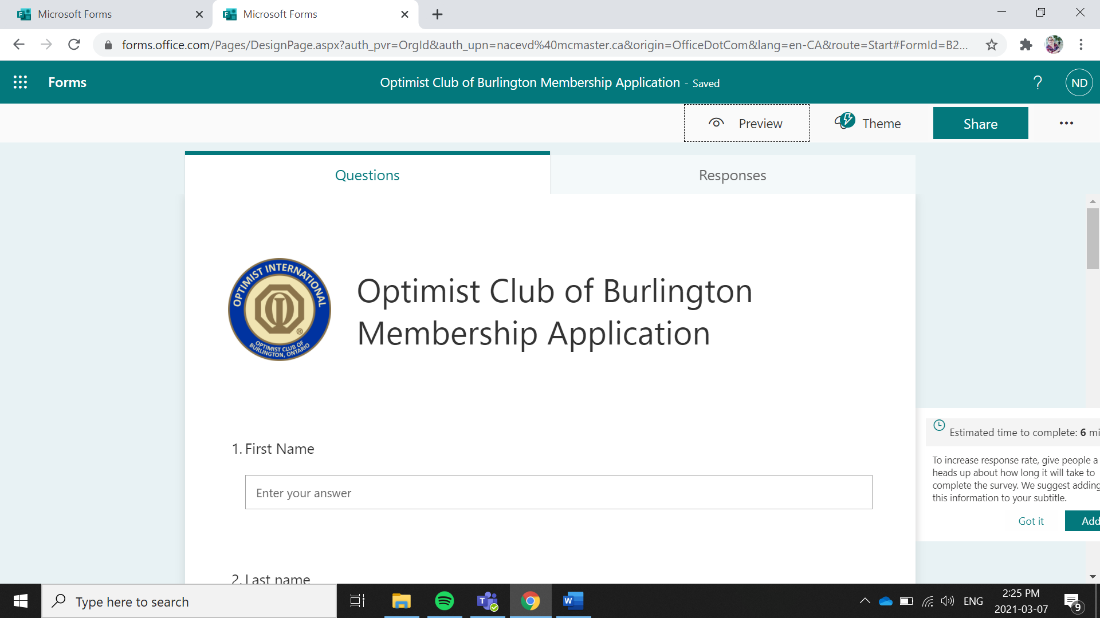

- You can now share the form through a link which can put anywhere you want to put it.
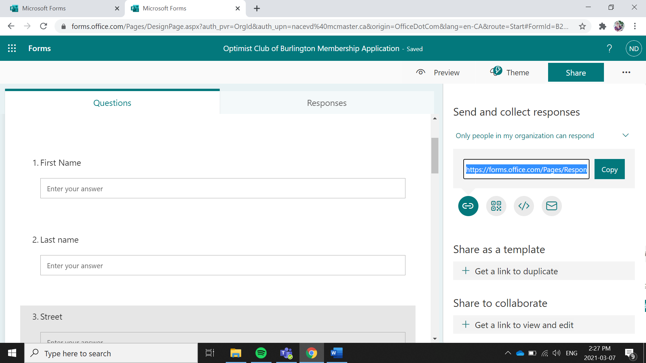

Creating a Membership Application Using Google Doc Forms
- Go to docs.google.com
- Sign into your google account or create one
- Select Blank Form
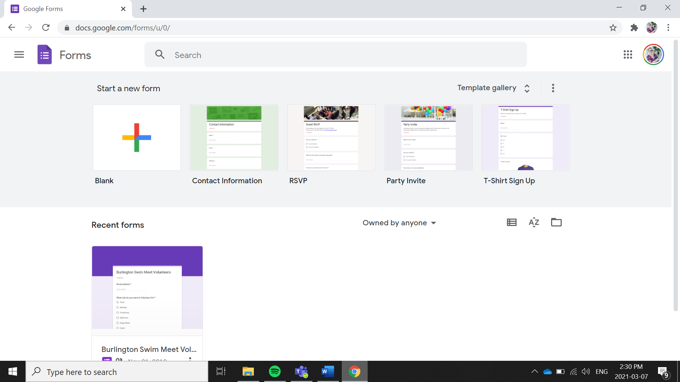
- Give your Form a Title. You can add your logo by selecting add image
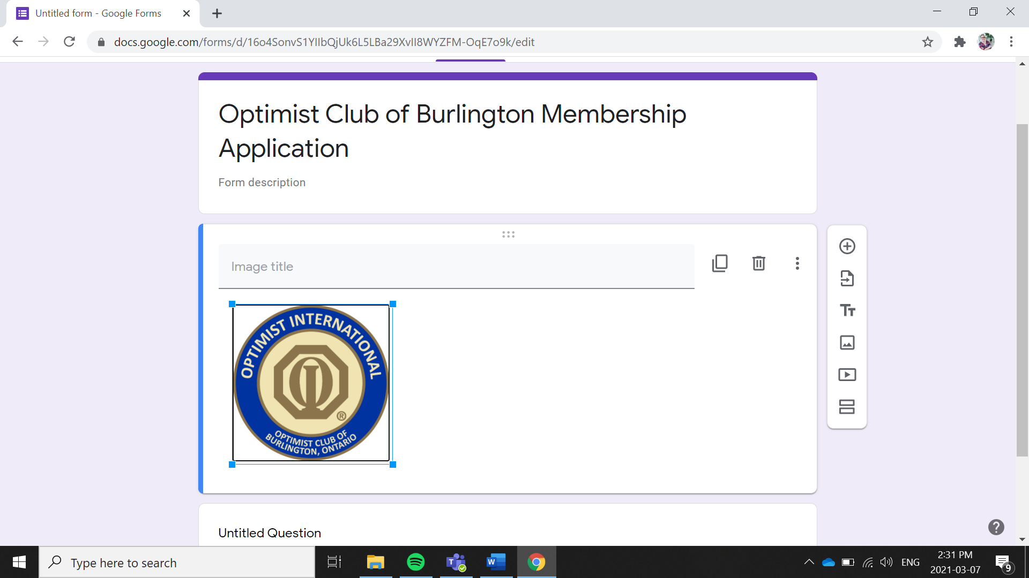
- Start Adding Questions select the + to add questions
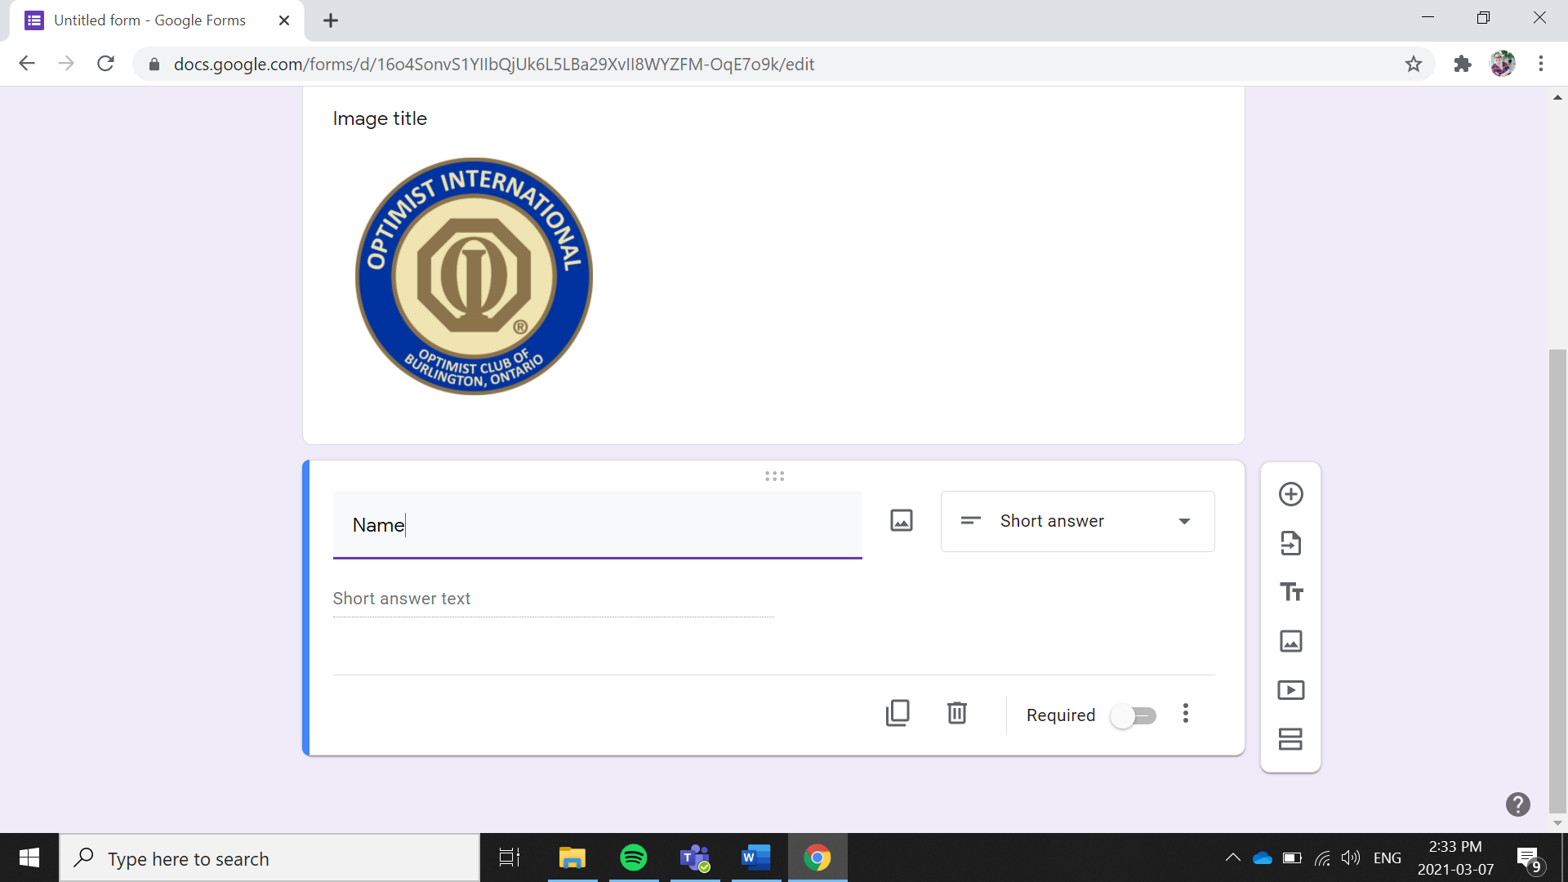
- You can select the type of question you would like to ask
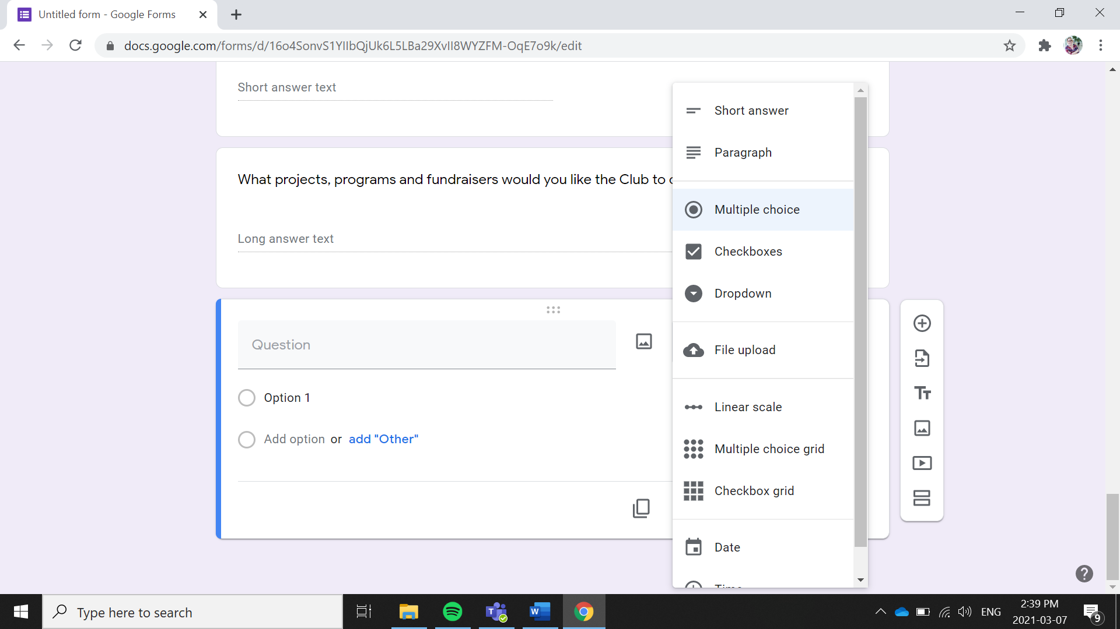

- Responses can be found in the response tab
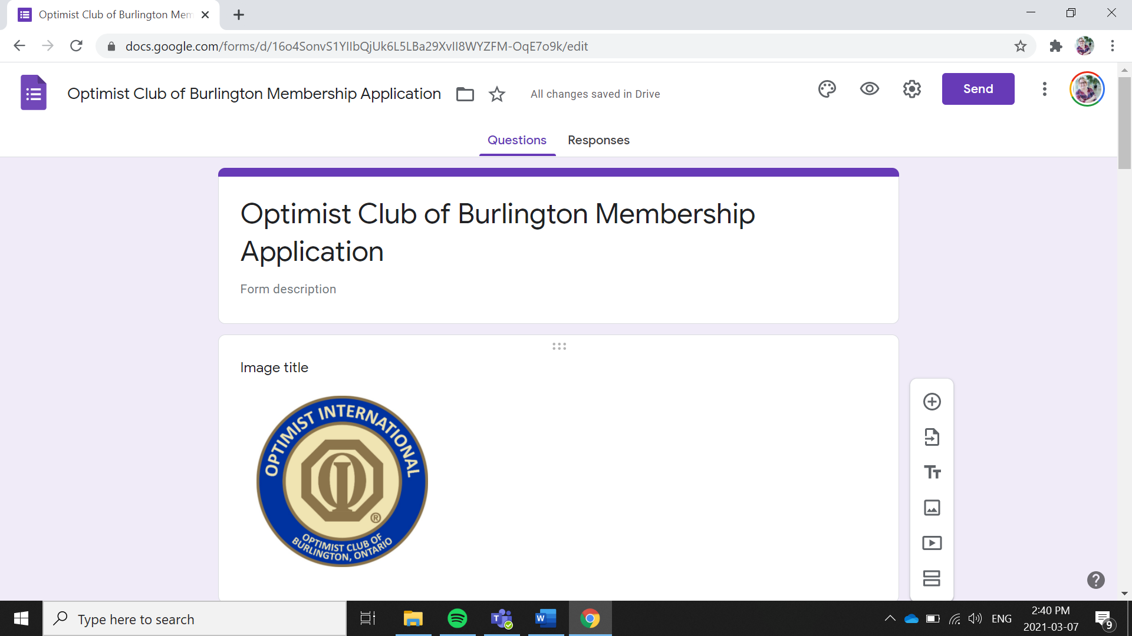
- You can preview your form.
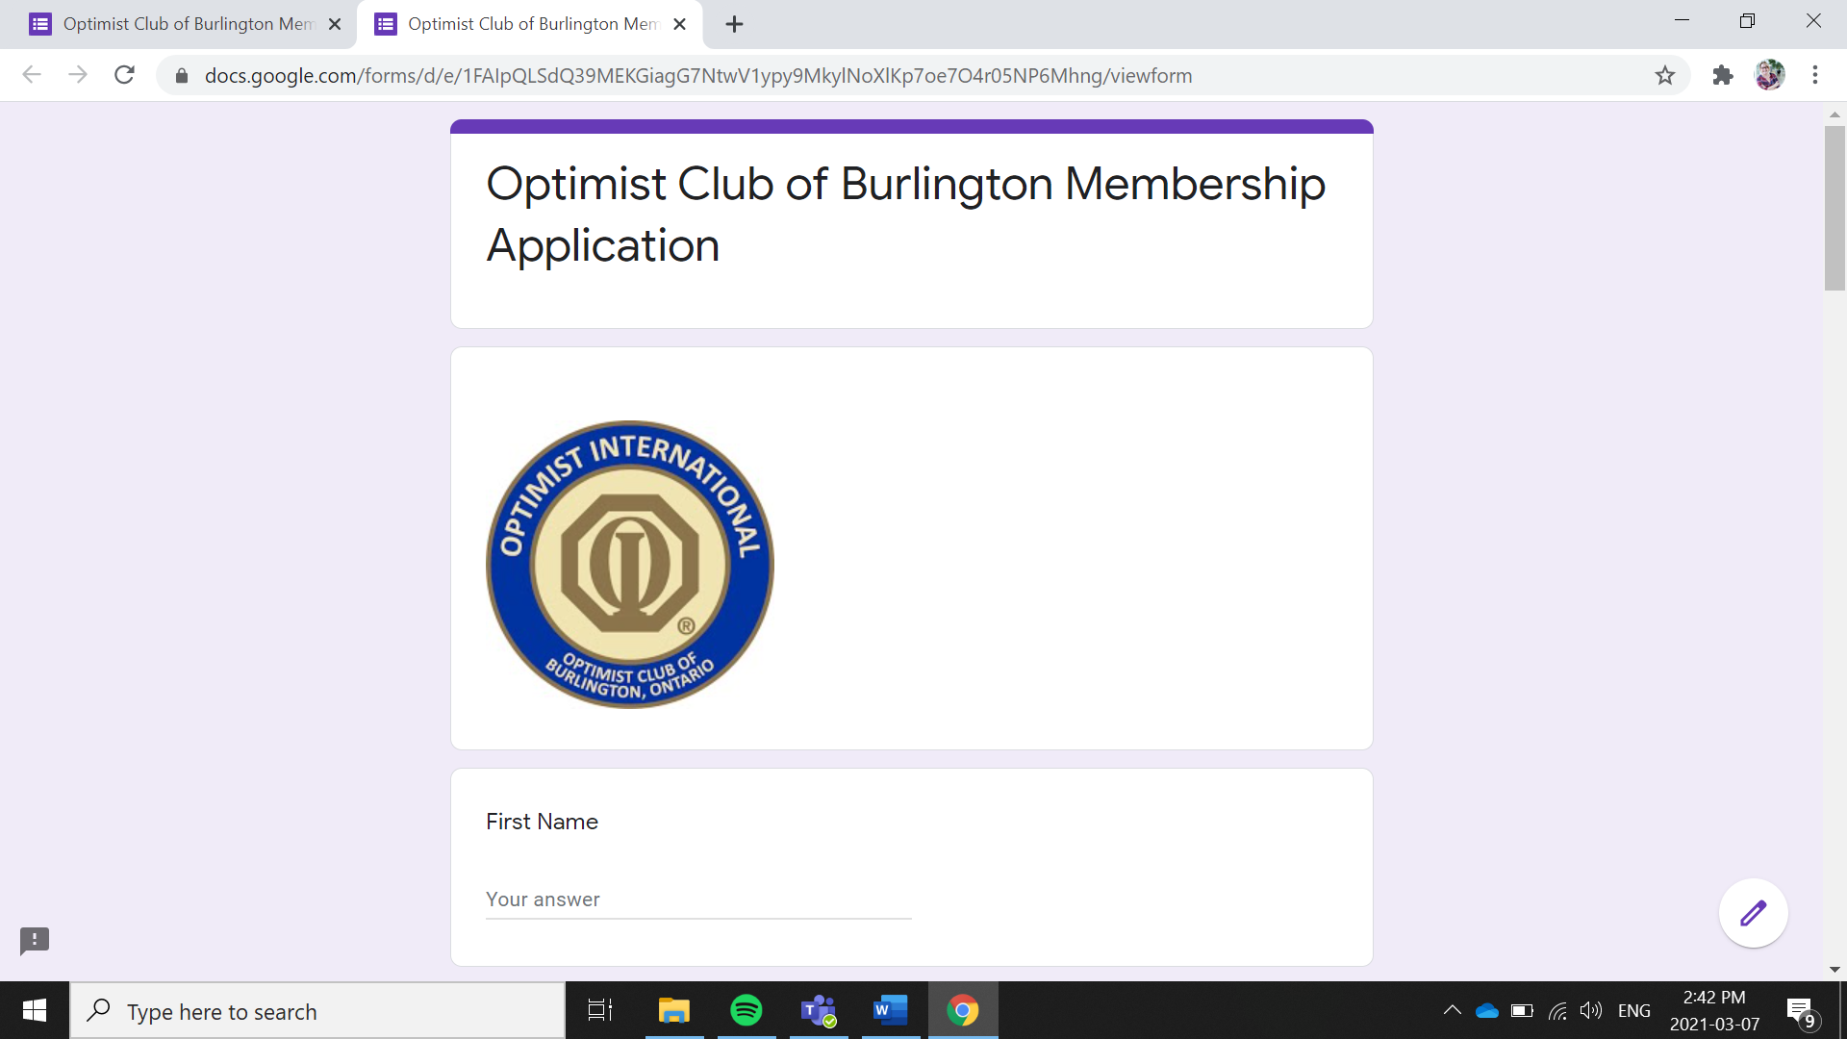

- You can then send the form via email, link, facebook or twitter
