FaceBook, Your Best Marketing Executive & Instagram, SnapChat, TikTok the Next Frontier of Promotion
Creating A FaceBook Event
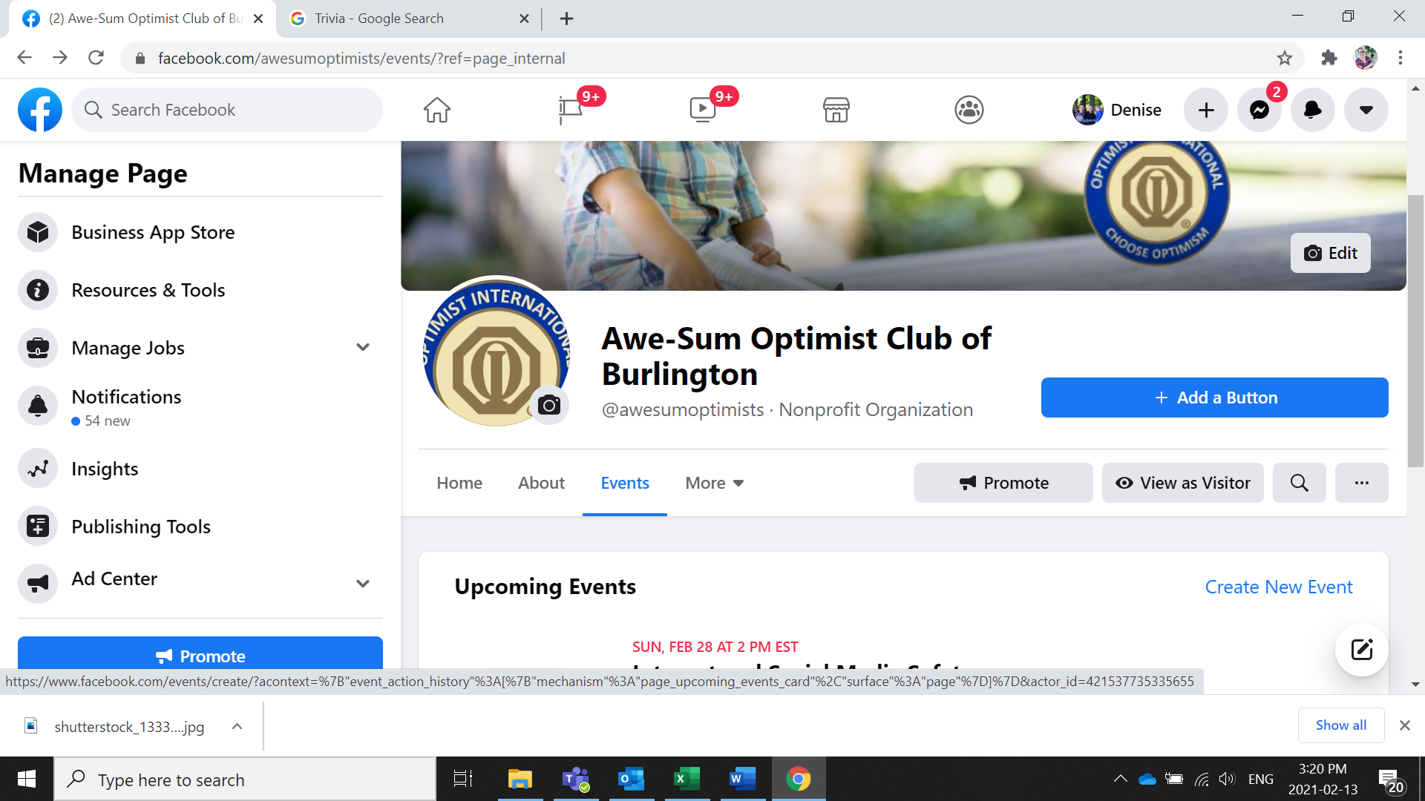
On your Facebook page, Go to your events Tab and select Create New Event

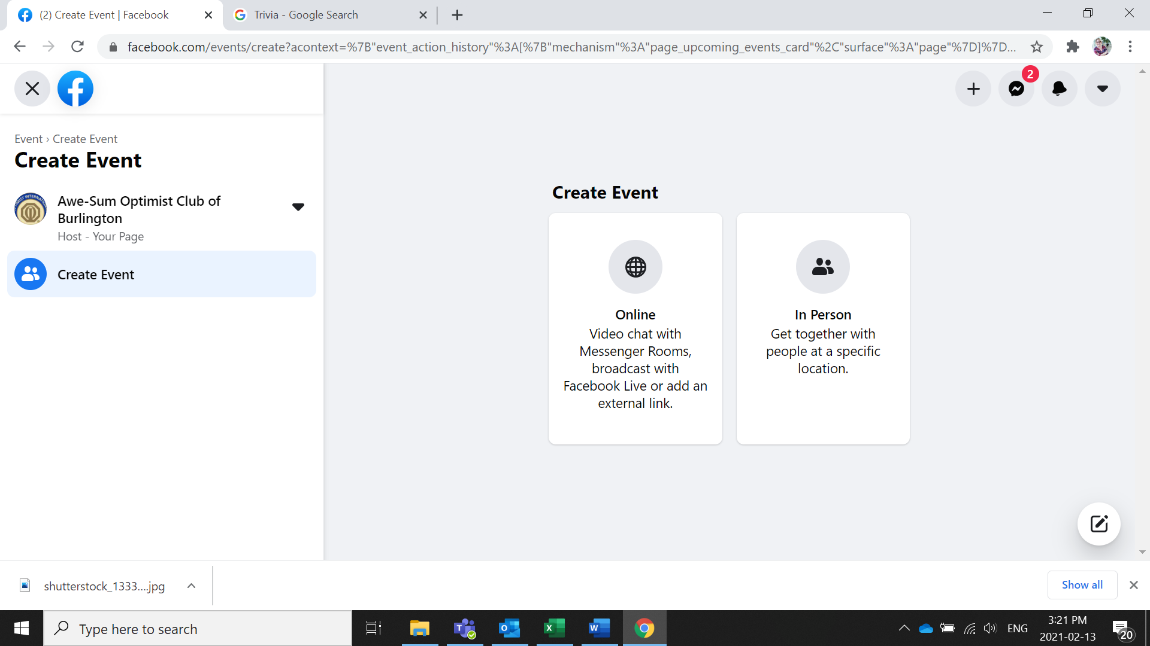
Select Online or In Person

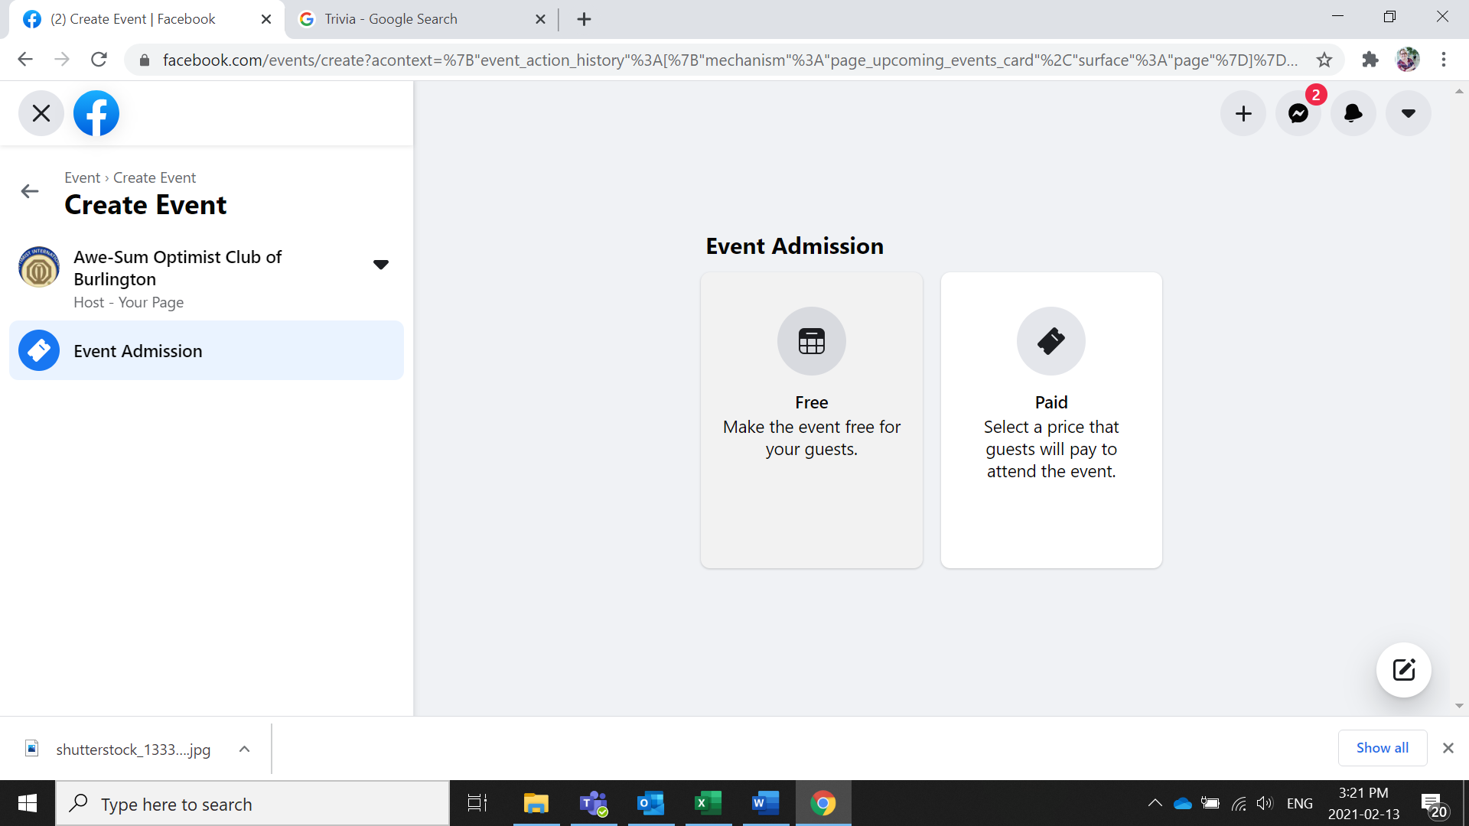
Select whether it is a free event or if there is a cost for it

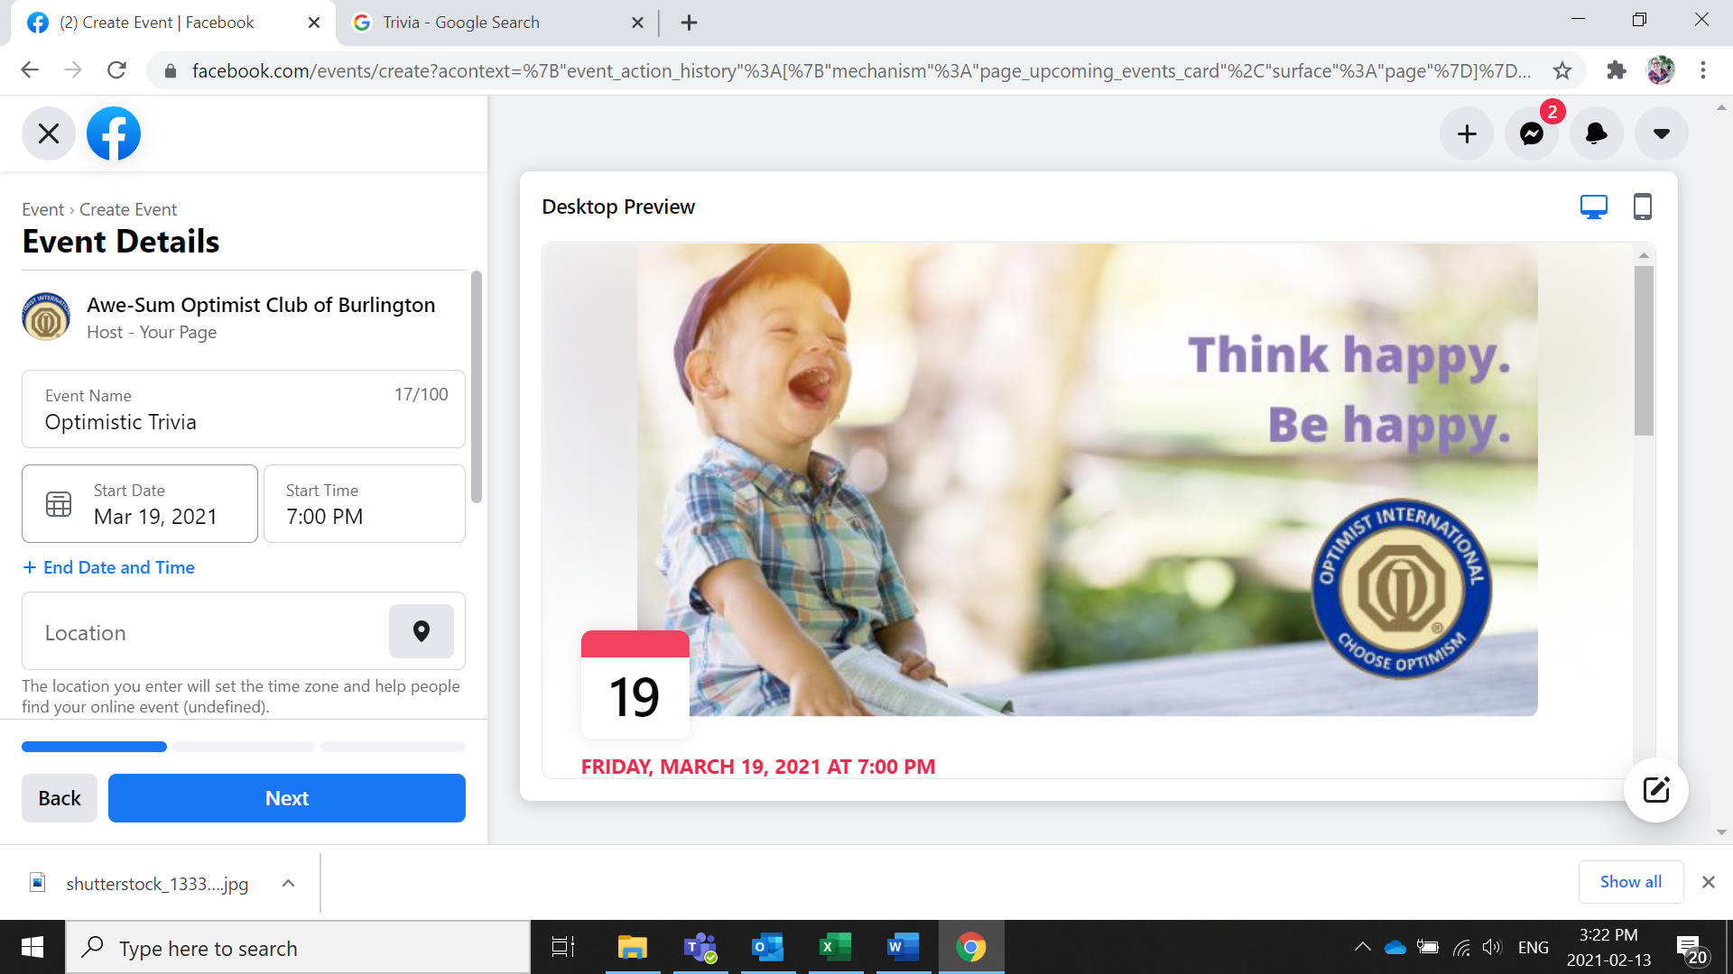
Enter your event details

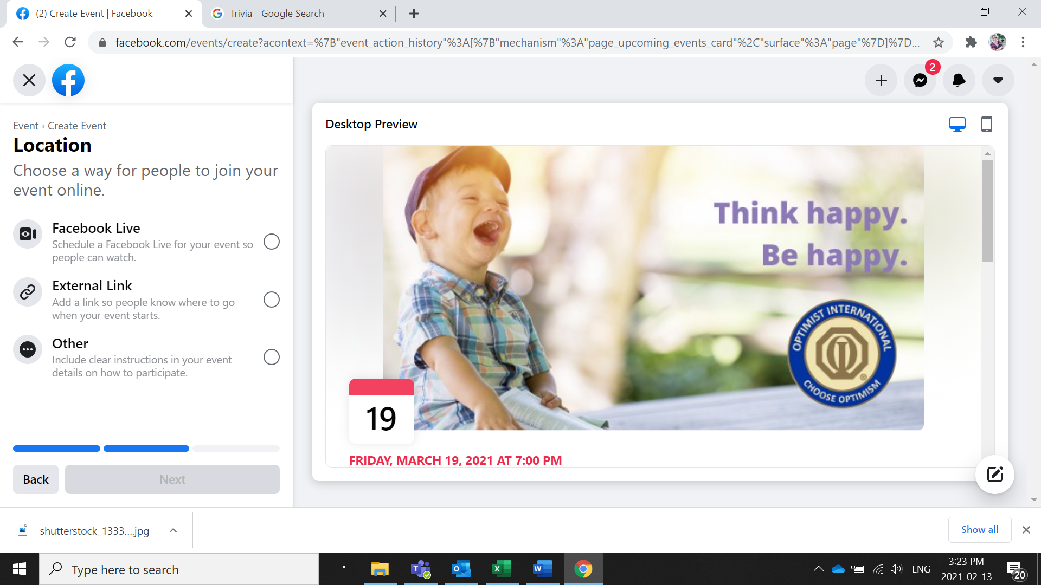
Select how, if you are using zoom select External link or other

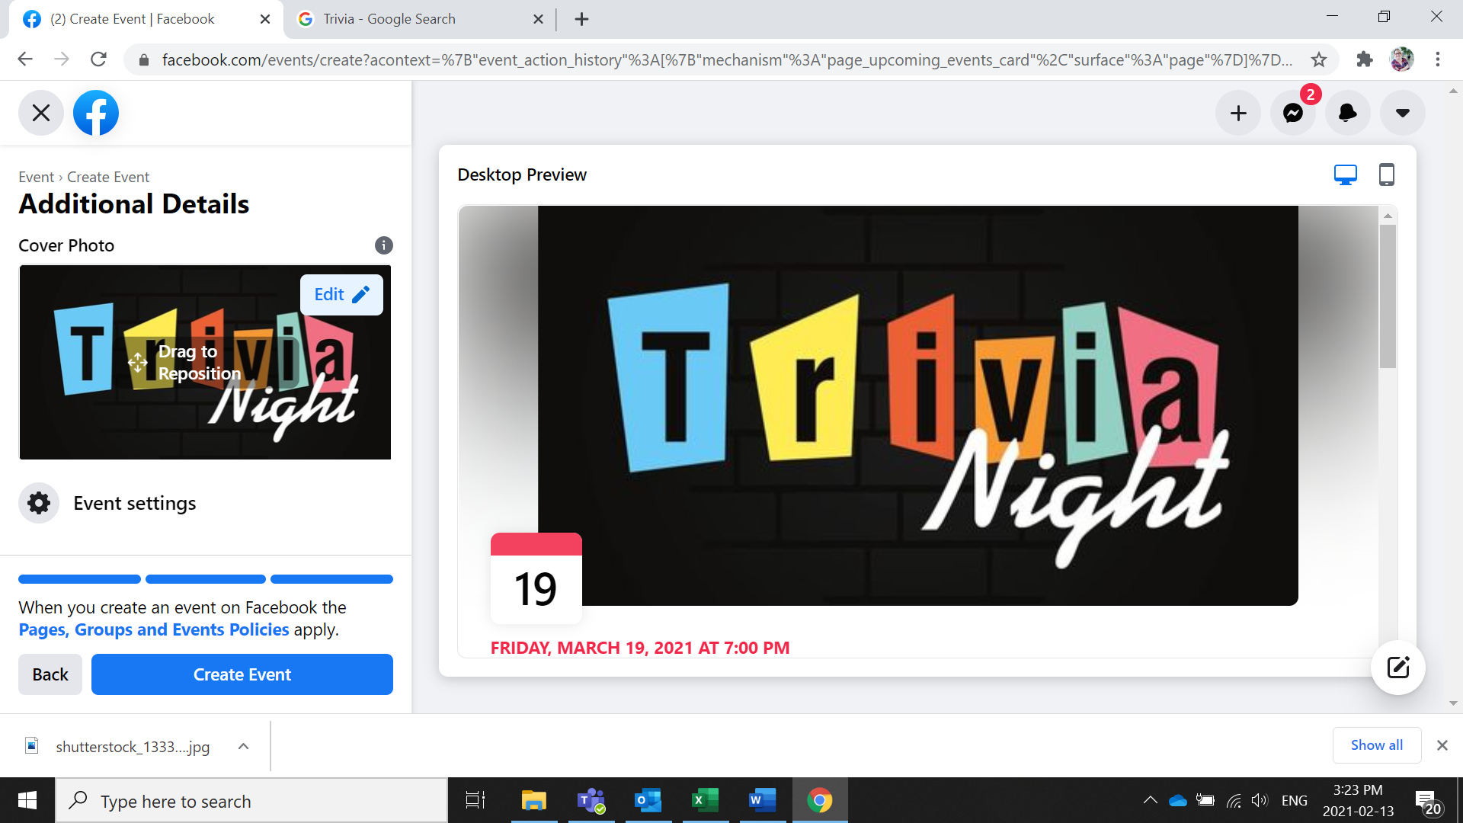
Change your Event Cover Photo and create your event
Now you can invite people to attend your event. Go into your event and select the Invite button
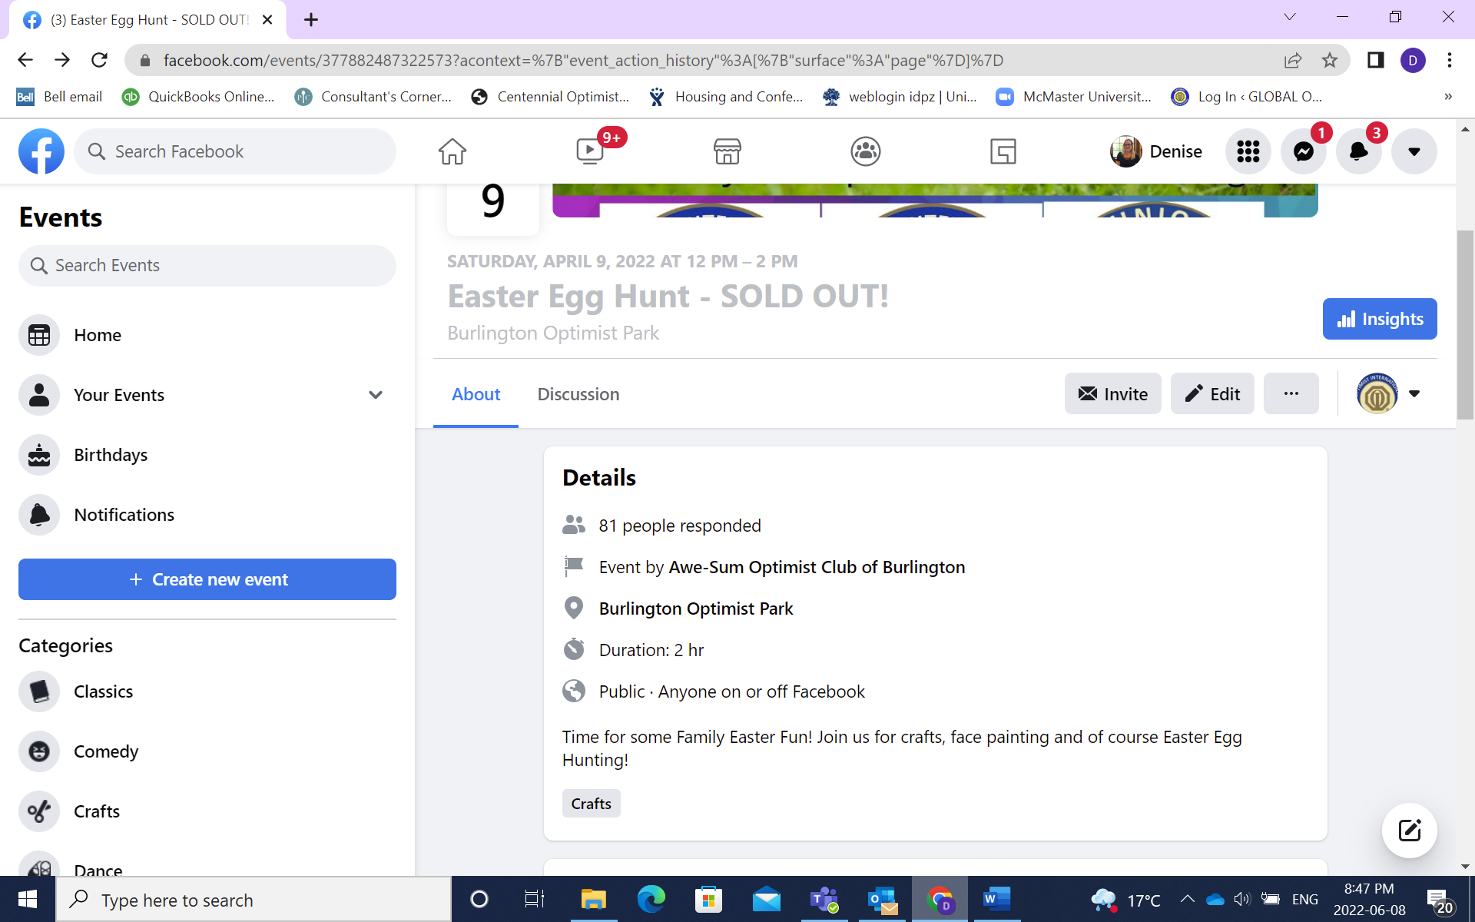

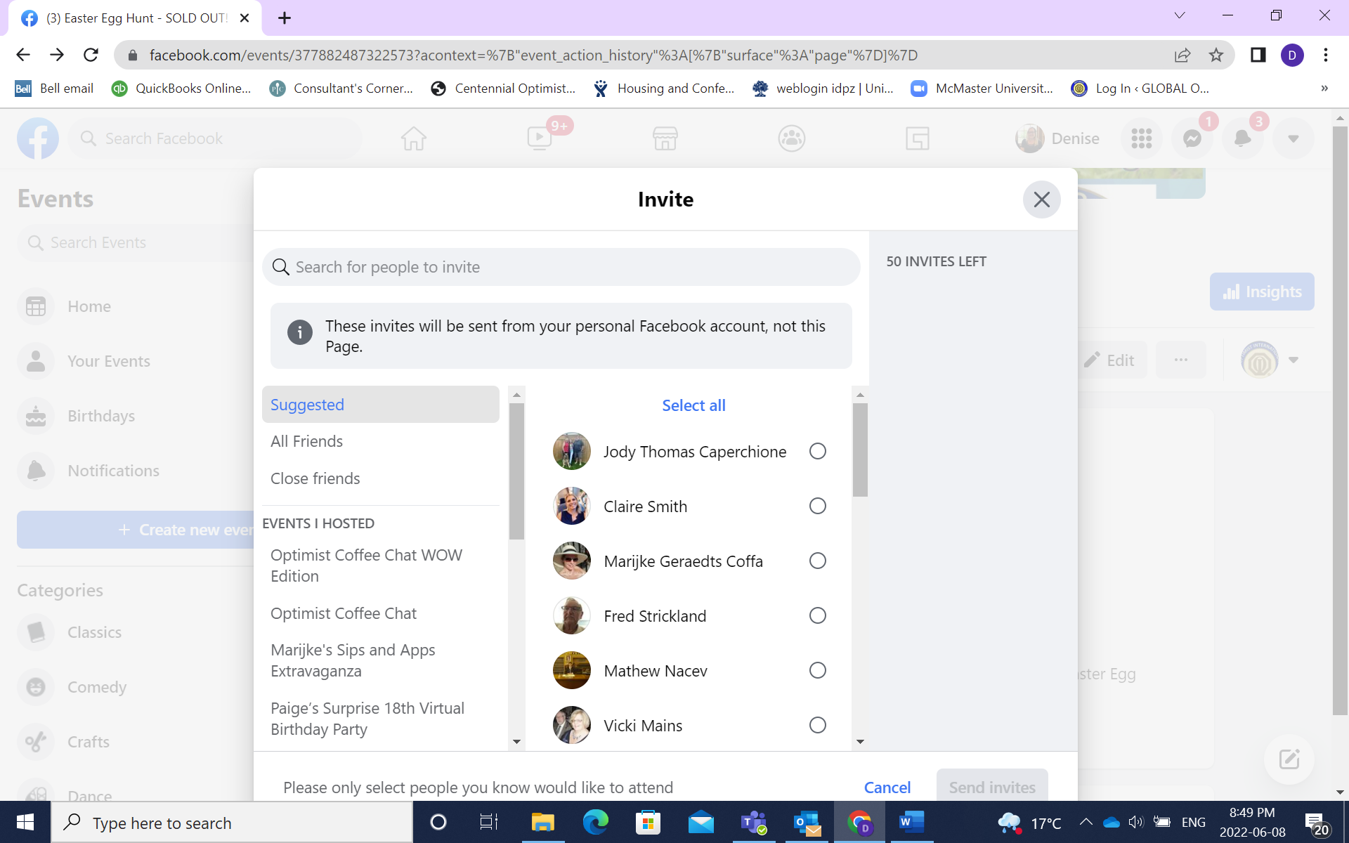
Your list of contacts will come and you can select which friends you want to send the invite to
You can also share the event to other pages by clicking on the 3 dots
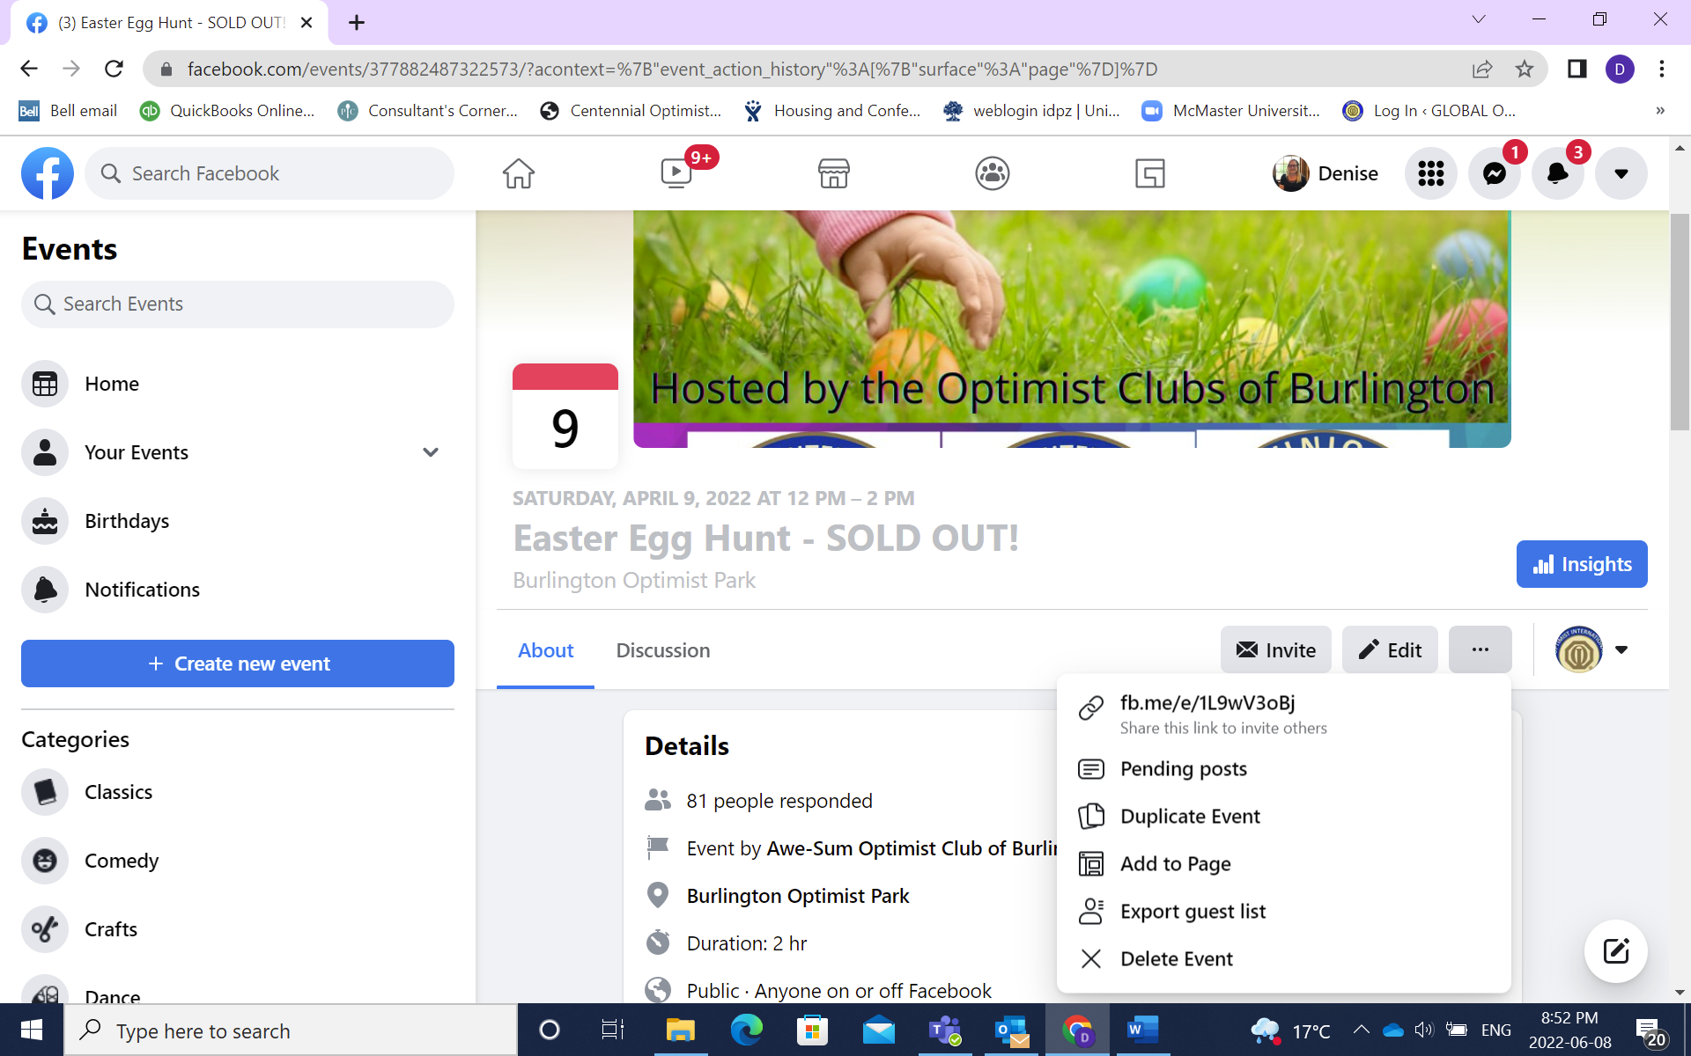
Select Add to a page
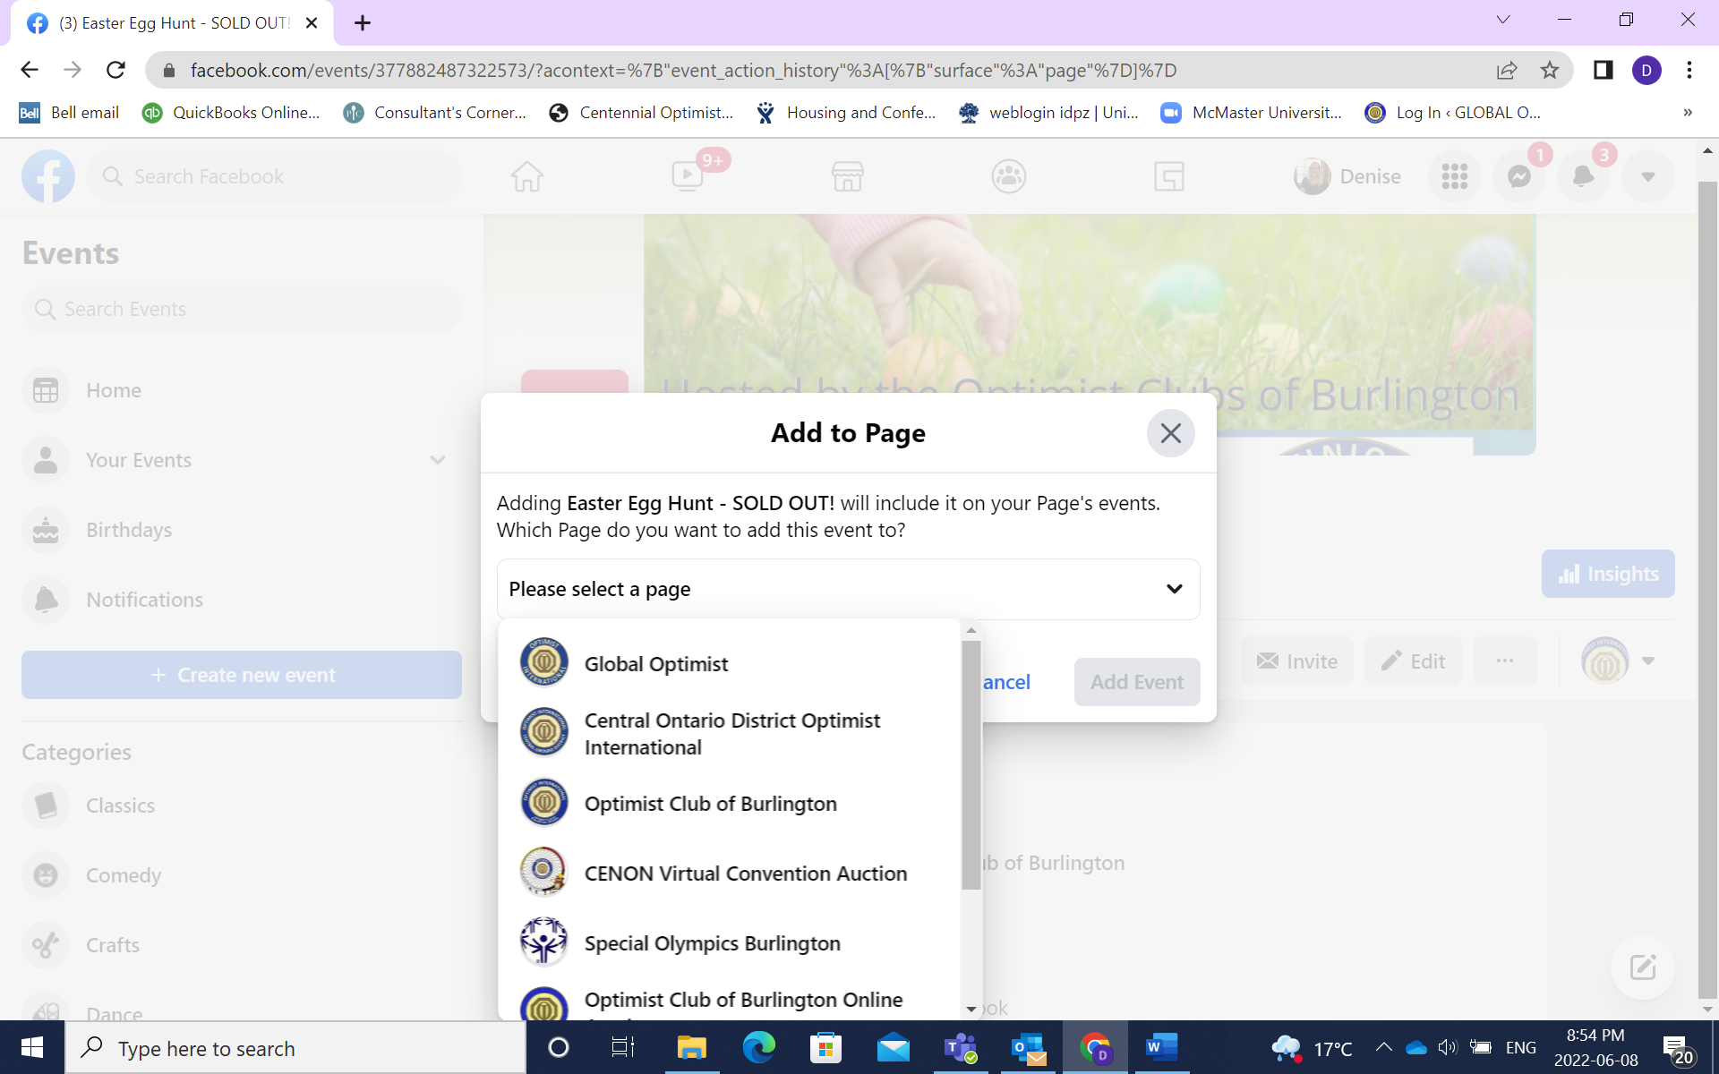
The list of pages you manage will come up and you can select the page you want to share to
Using Facebook Groups
Facebook Groups are a place to communicate about shared interests with certain people. You can create groups for family events, communities, sports or any interest. Many communities use Facebook Groups to grow a close knit community and connect. Optimist Clubs can leverage groups to promote events and recruit potential members. In order to post in a group you must be a member of the group, some groups are open and public, others are private and require approval to join.
On your Facebook New Feed select Groups

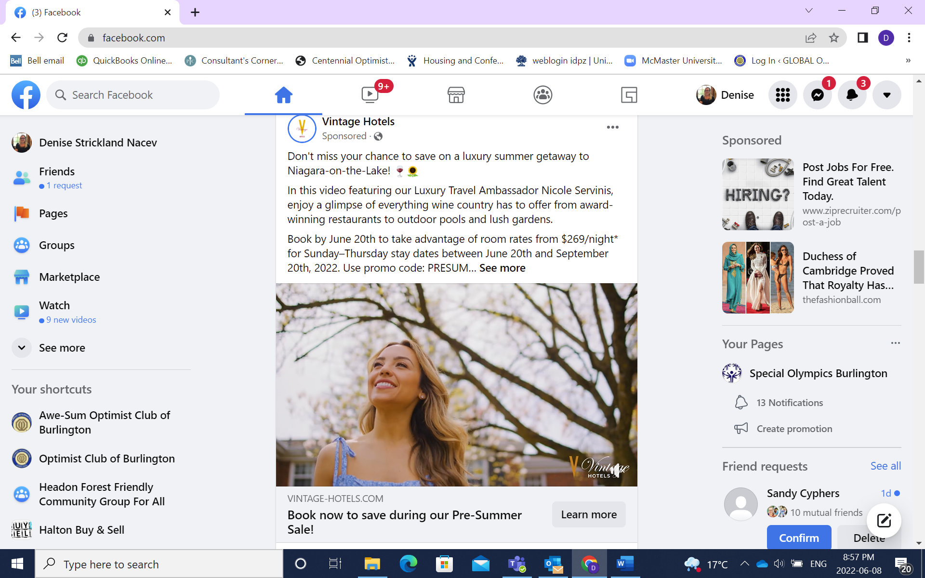

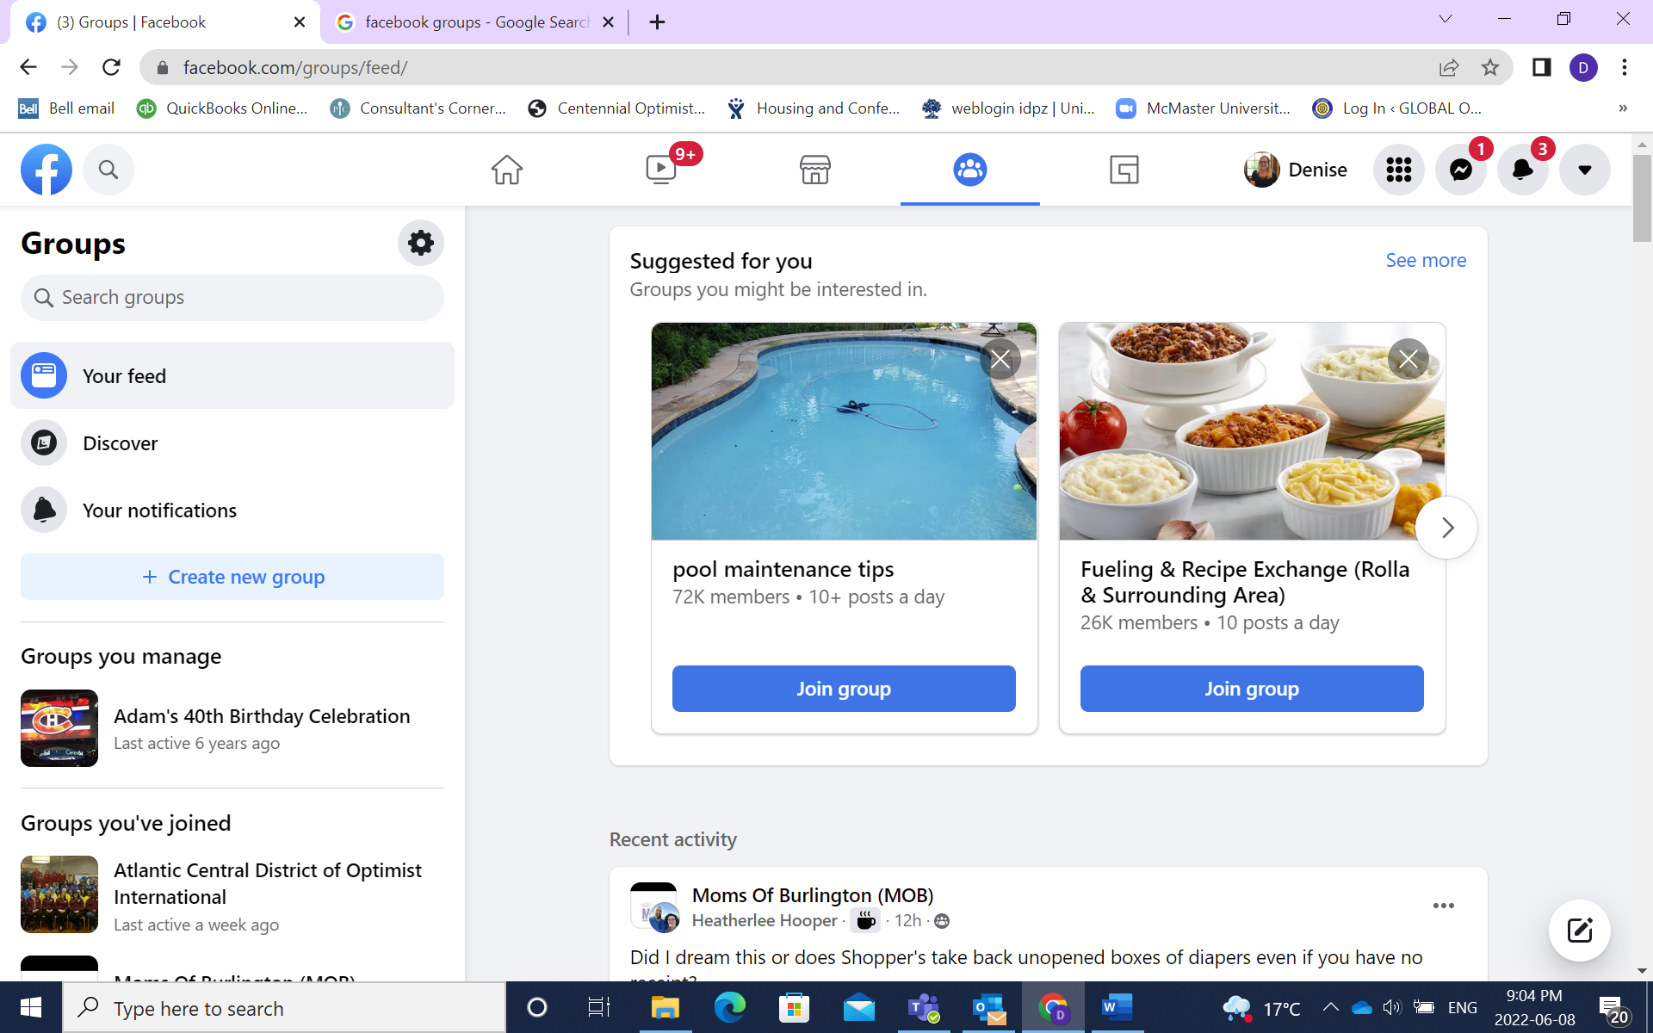
If you know the name of the group you can use the search field to search by name. If you want to discover what groups you might be interested in select Discover.
In the side panel will be groups that are suggested for you based on your interests
Lists the groups you have joined
Lists the recent activity that has happened in your groups

When you select Discover a list will come up of the groups your friends are in
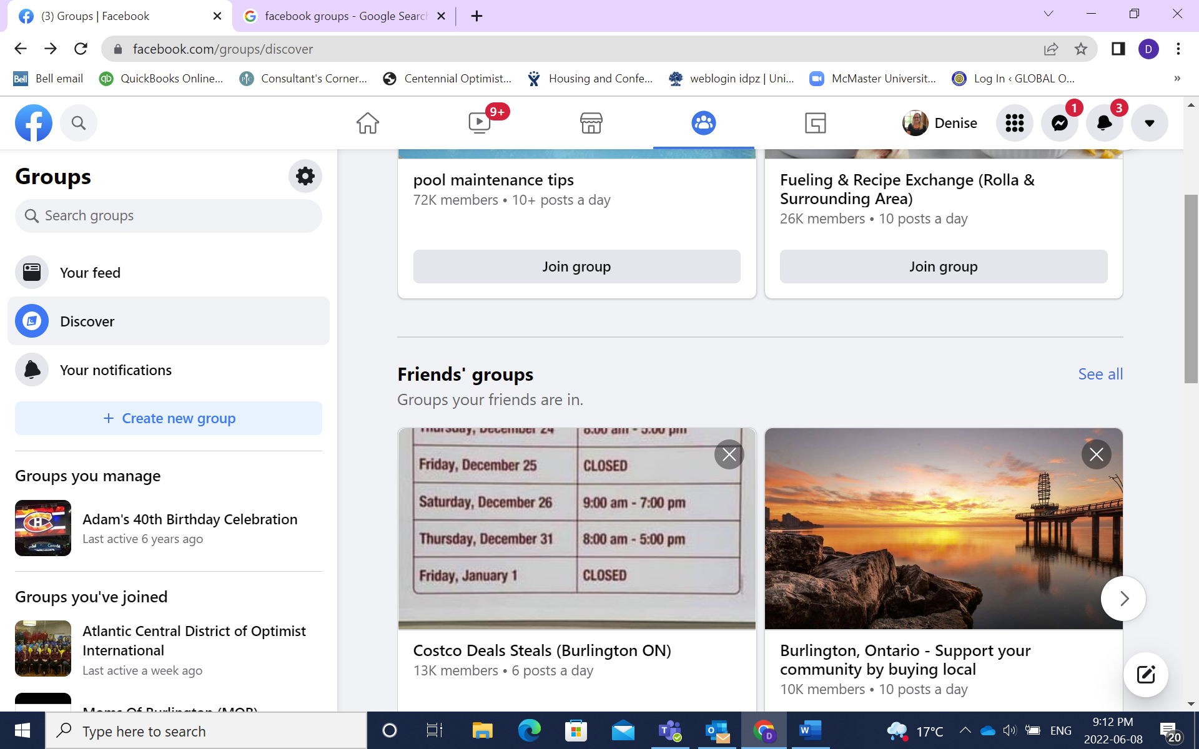
Scroll down and you will find groups that are popular in your area
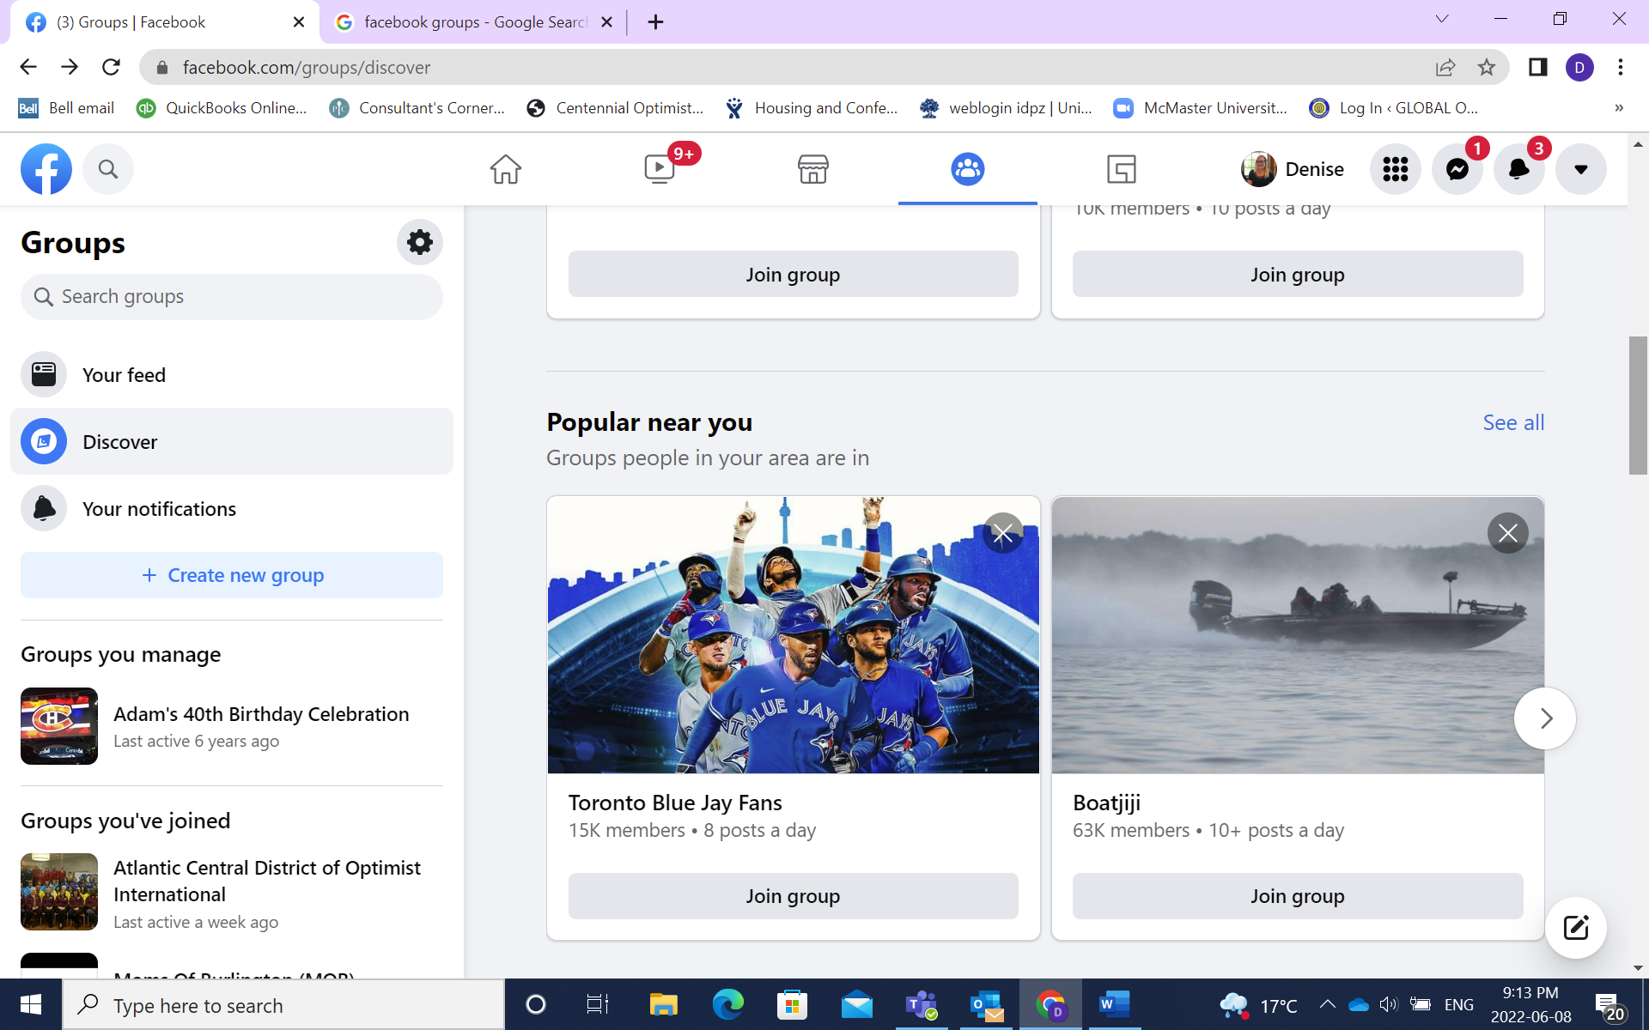
To join a group select Join Group, which will send a request to join. You will get notification when you have been joined to the group and posts will start to appear in your news feed
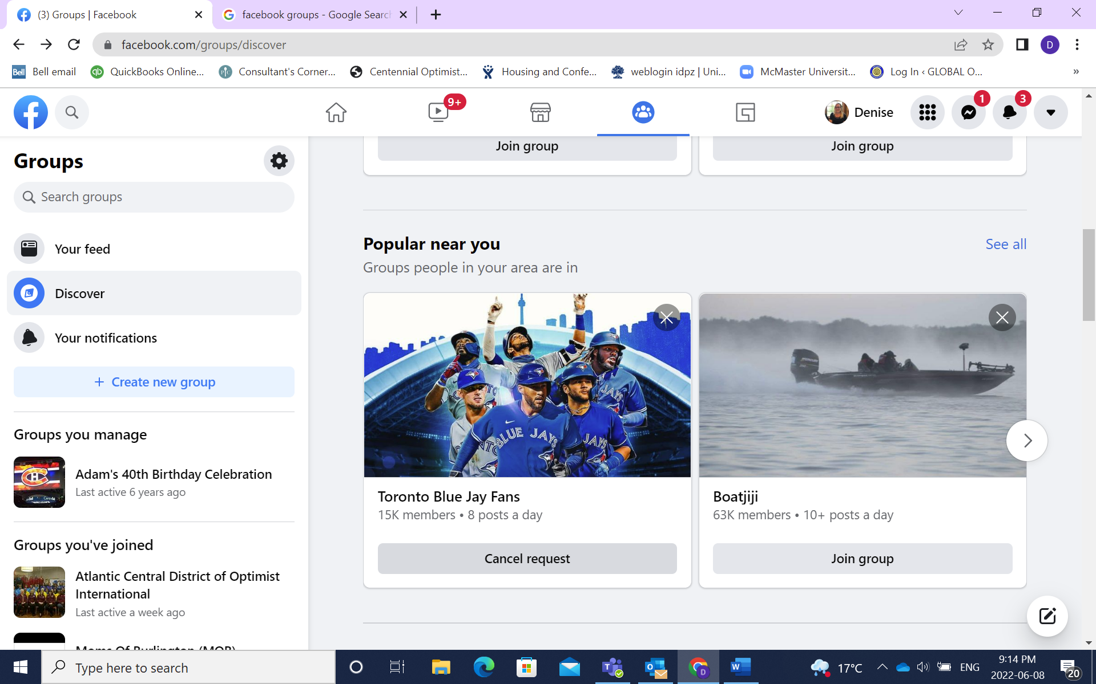
This is a good group to join if you haven’t already!
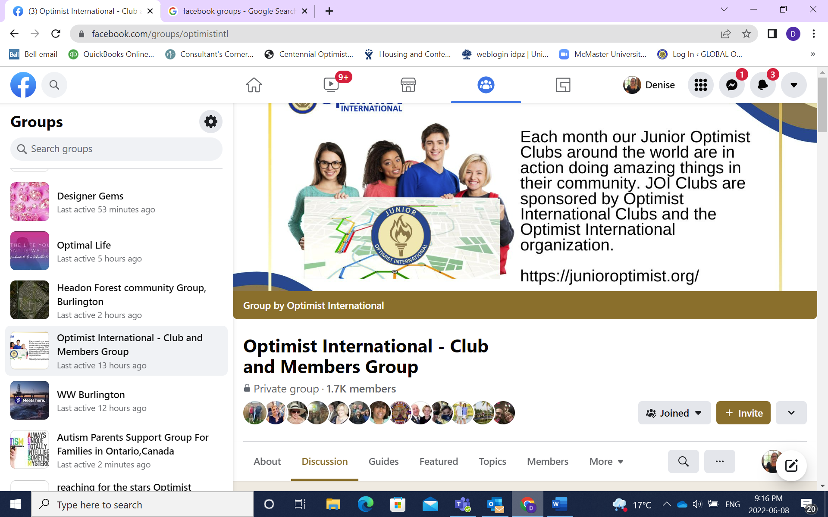
Creating a Group
Maybe you want to create your own group for your club. Once you create a group you can then post information, create events and share information with the members of that group. The group members can also post and share information. Select Create Group
\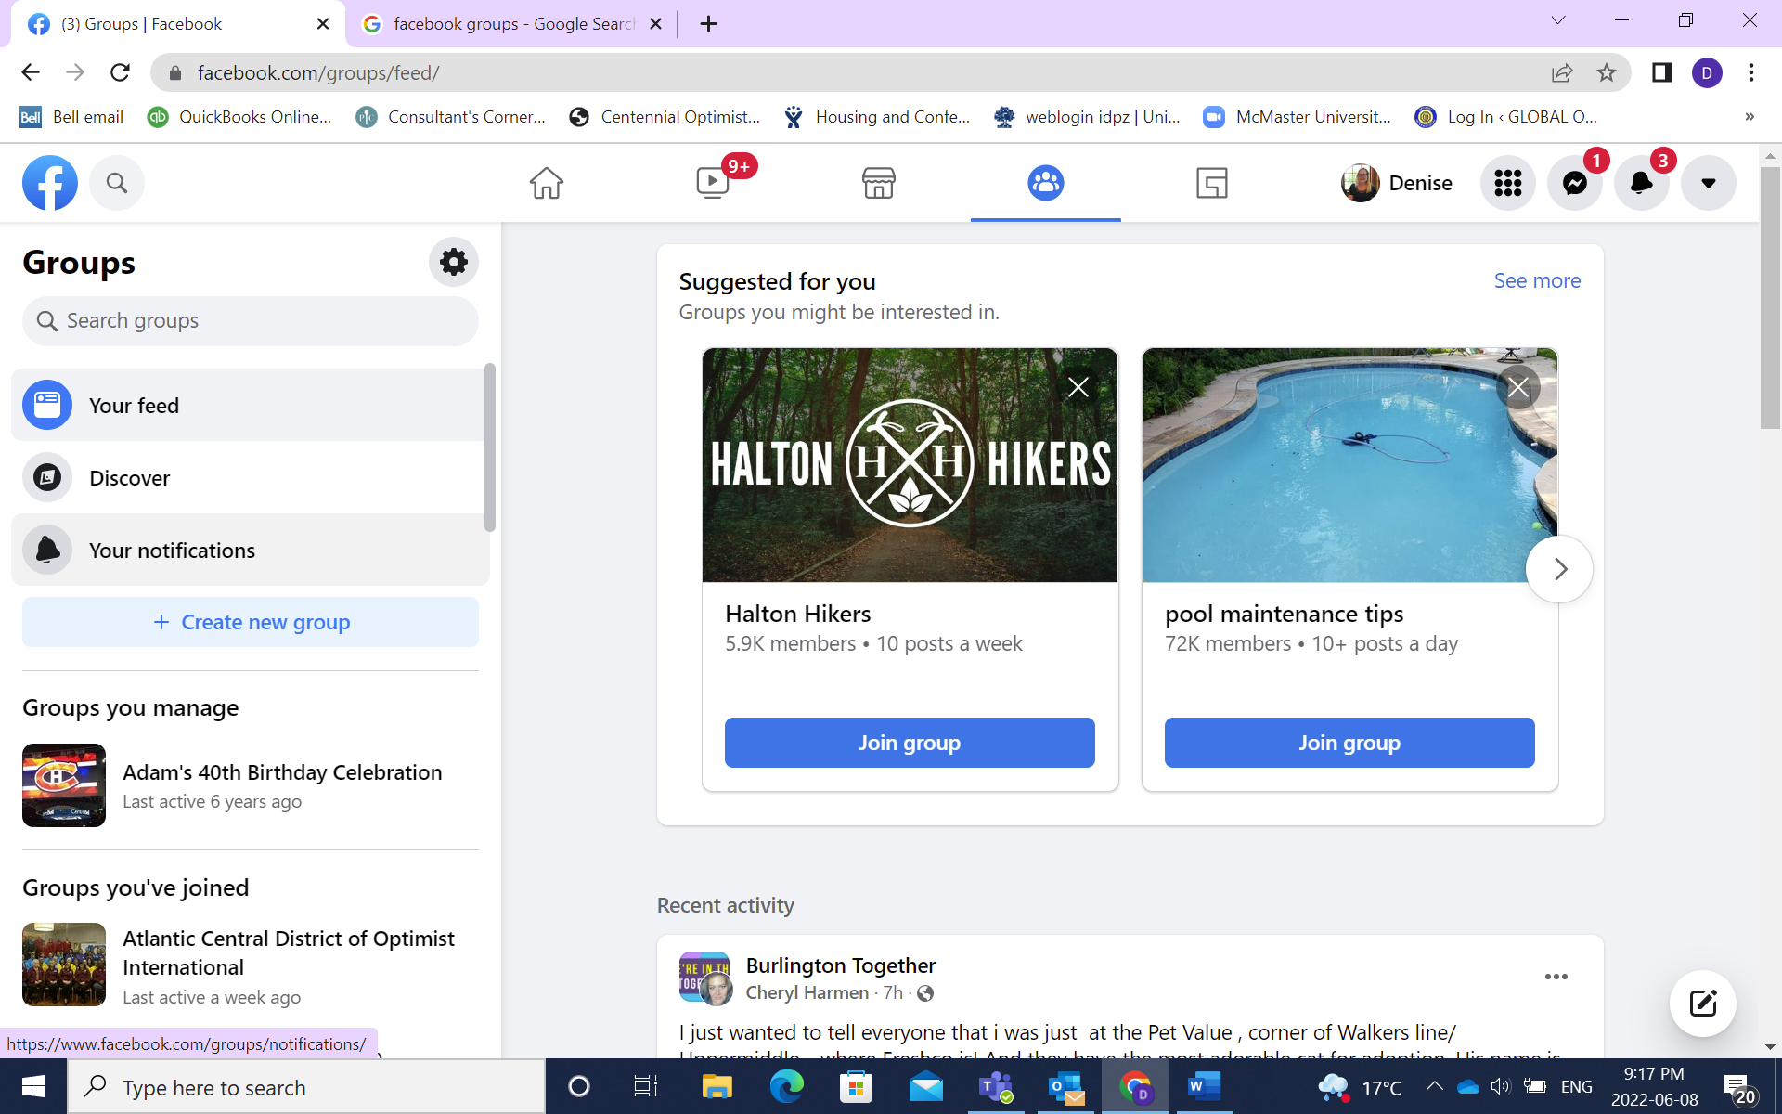

Give your group a name and decide if you want it to be Public or Private. Public Vs Private Groups: In a public group anyone can see who is a member and what they post. In a Private Group only the members can see what other members post and who is a member.
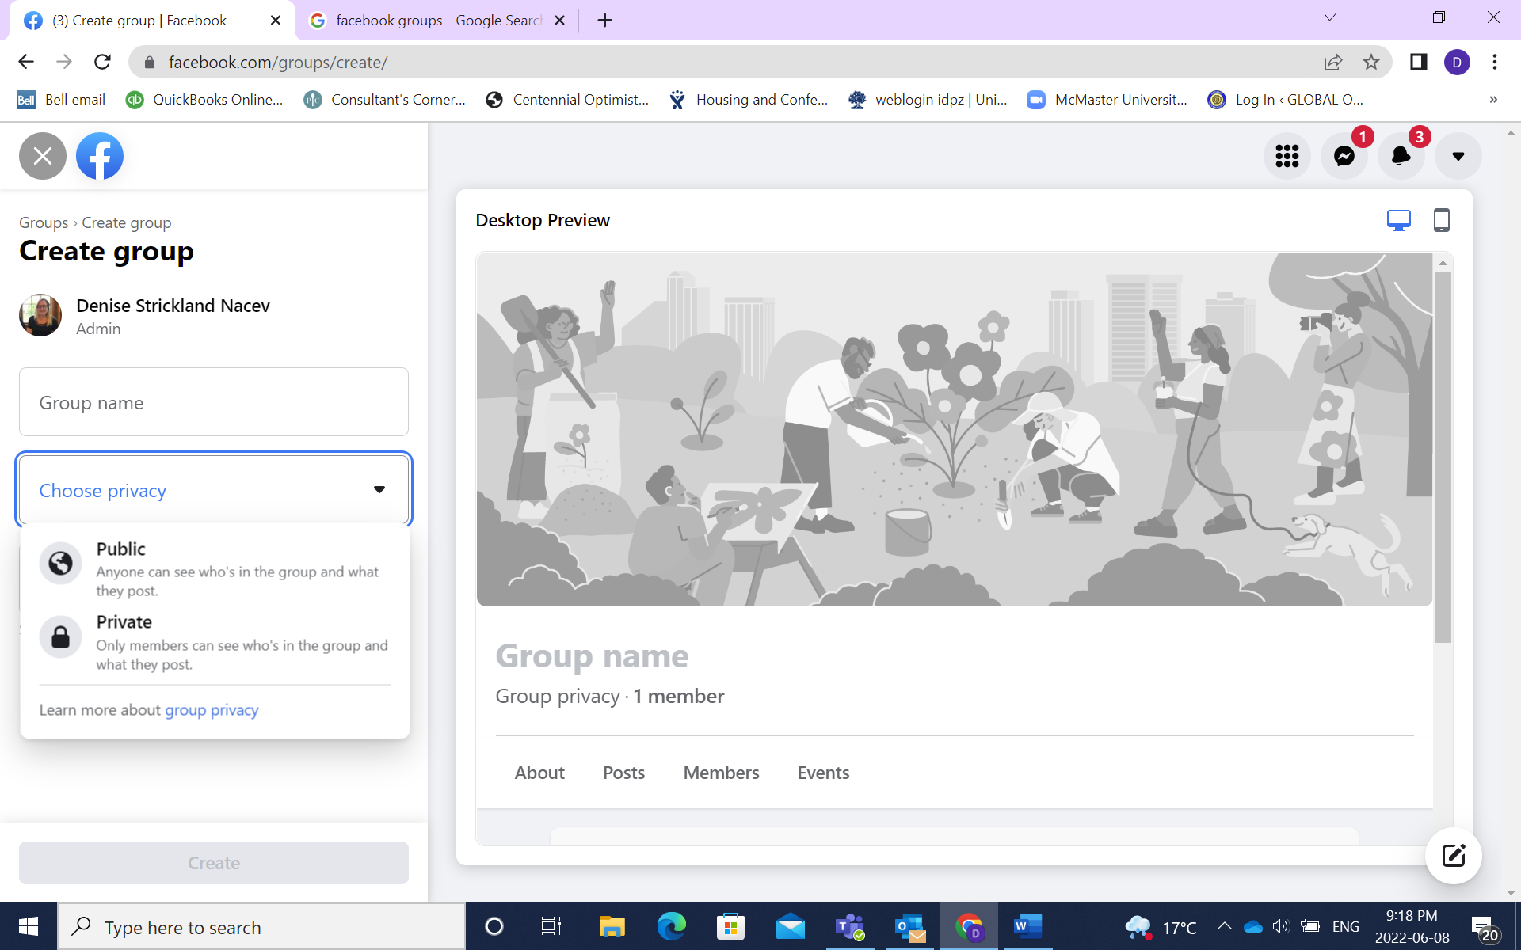
Then you invite people to become part of the group and select Create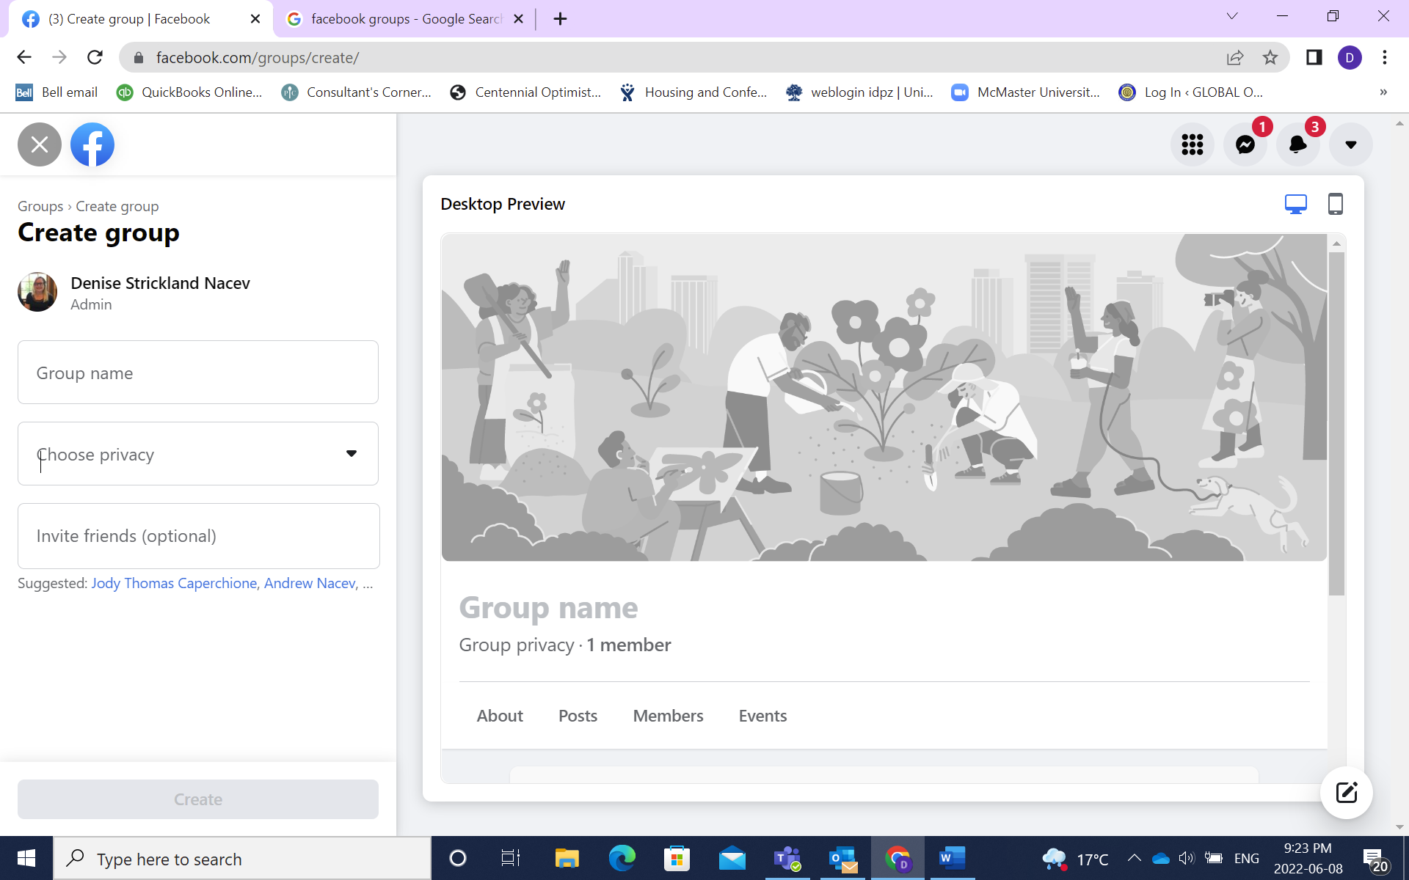

Boosting a Post or Event
Boosting a post or event can be an inexpensive way of sharing your event details and getting more people to attend. On the Post or the Event select Boost
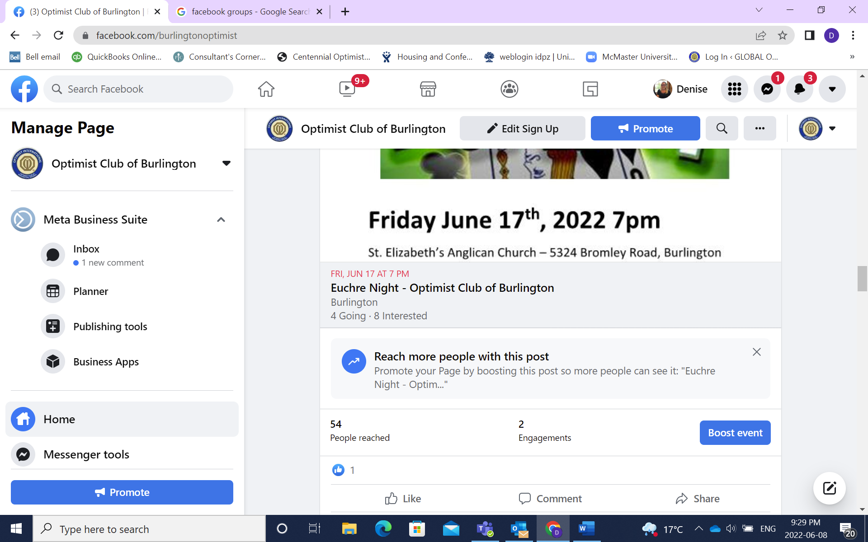

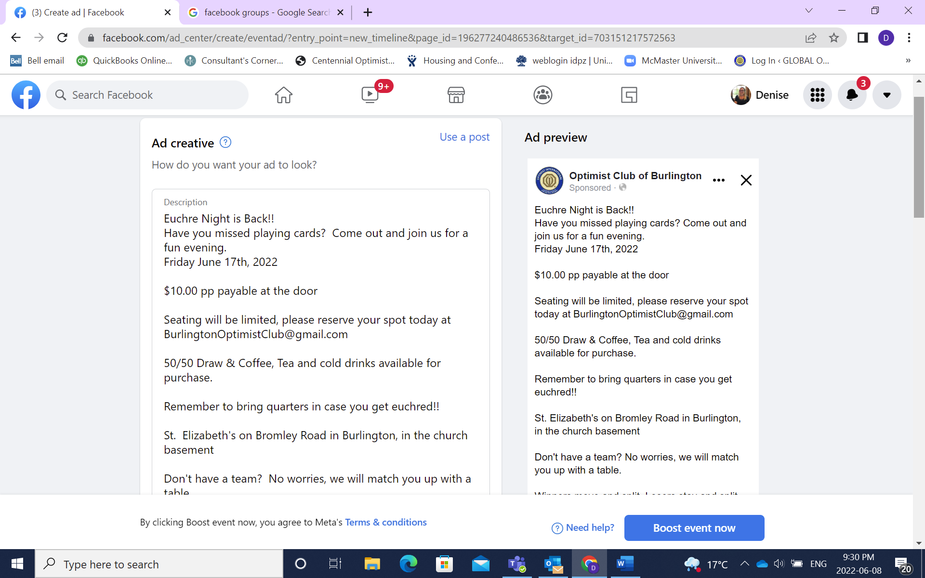
Scroll down to start entering details for your boost. You start by defining your audience
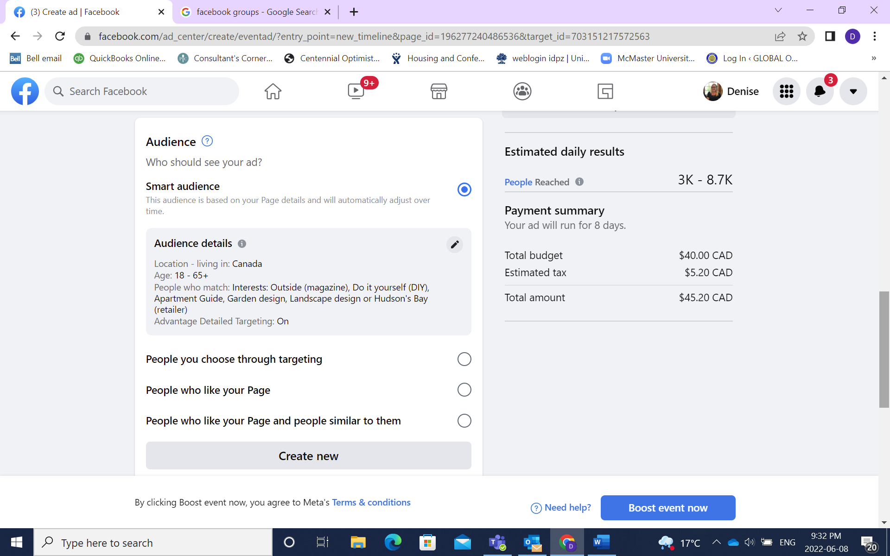

Select People you choose through targeting and this screen will allow you to select who you want to target

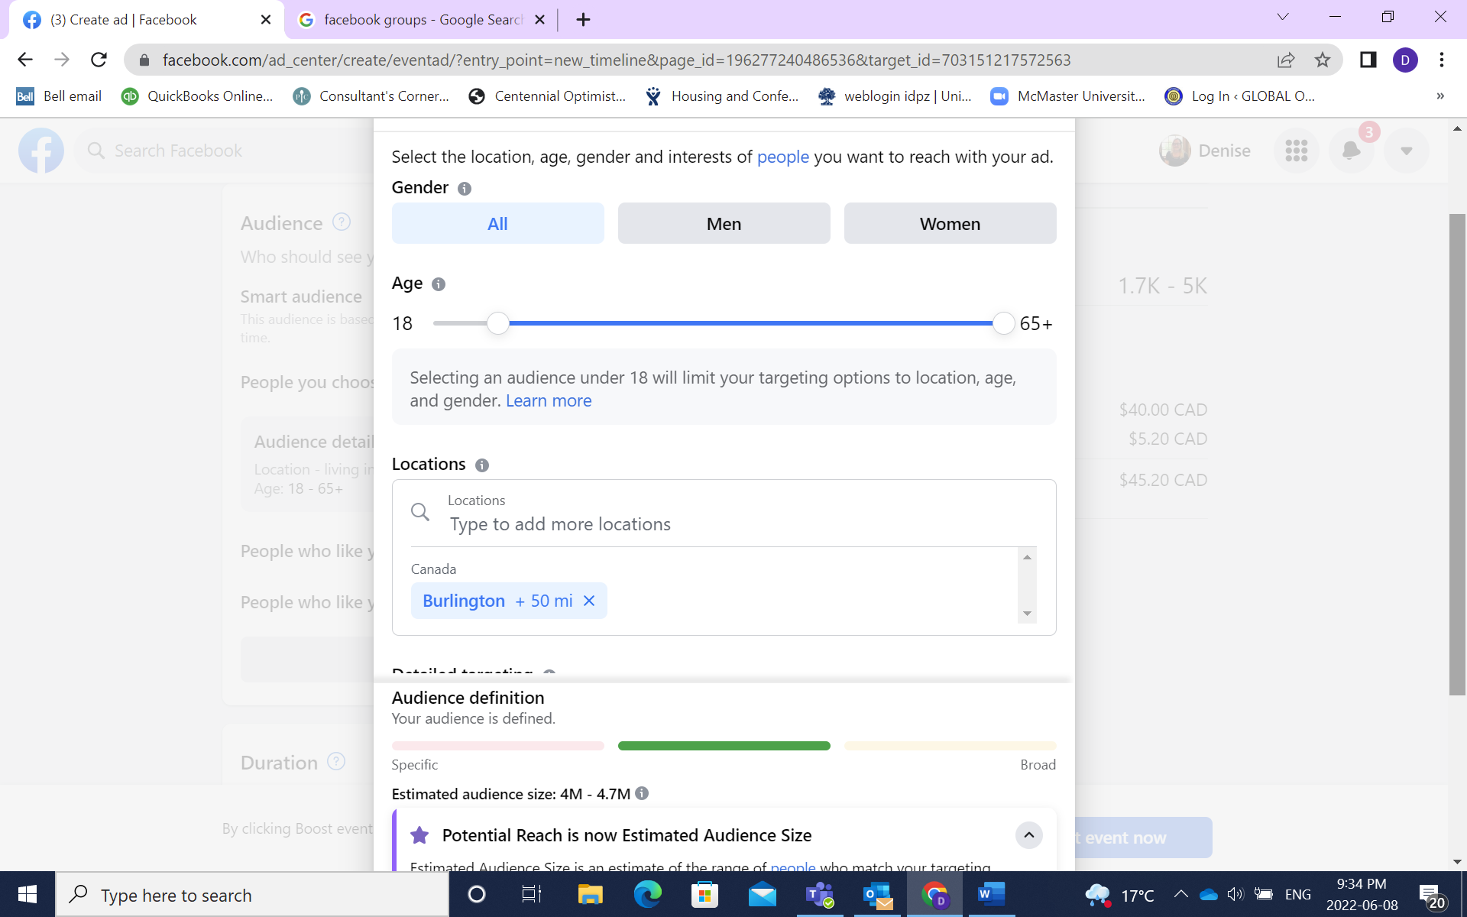
Here you can select Gender, the age range you want to target and what locations you want to target. This allows you to narrow your target to just your community
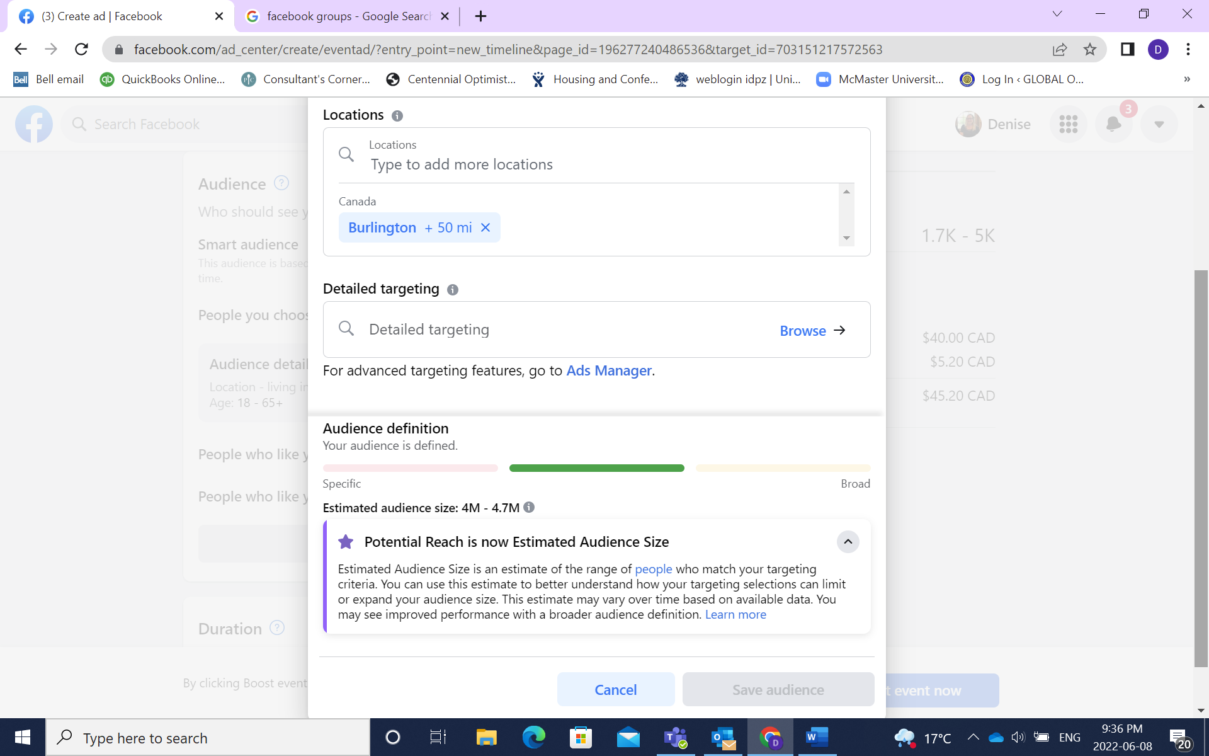
Detailed targeting allows you to target people who have listed the interests you select on their profile.
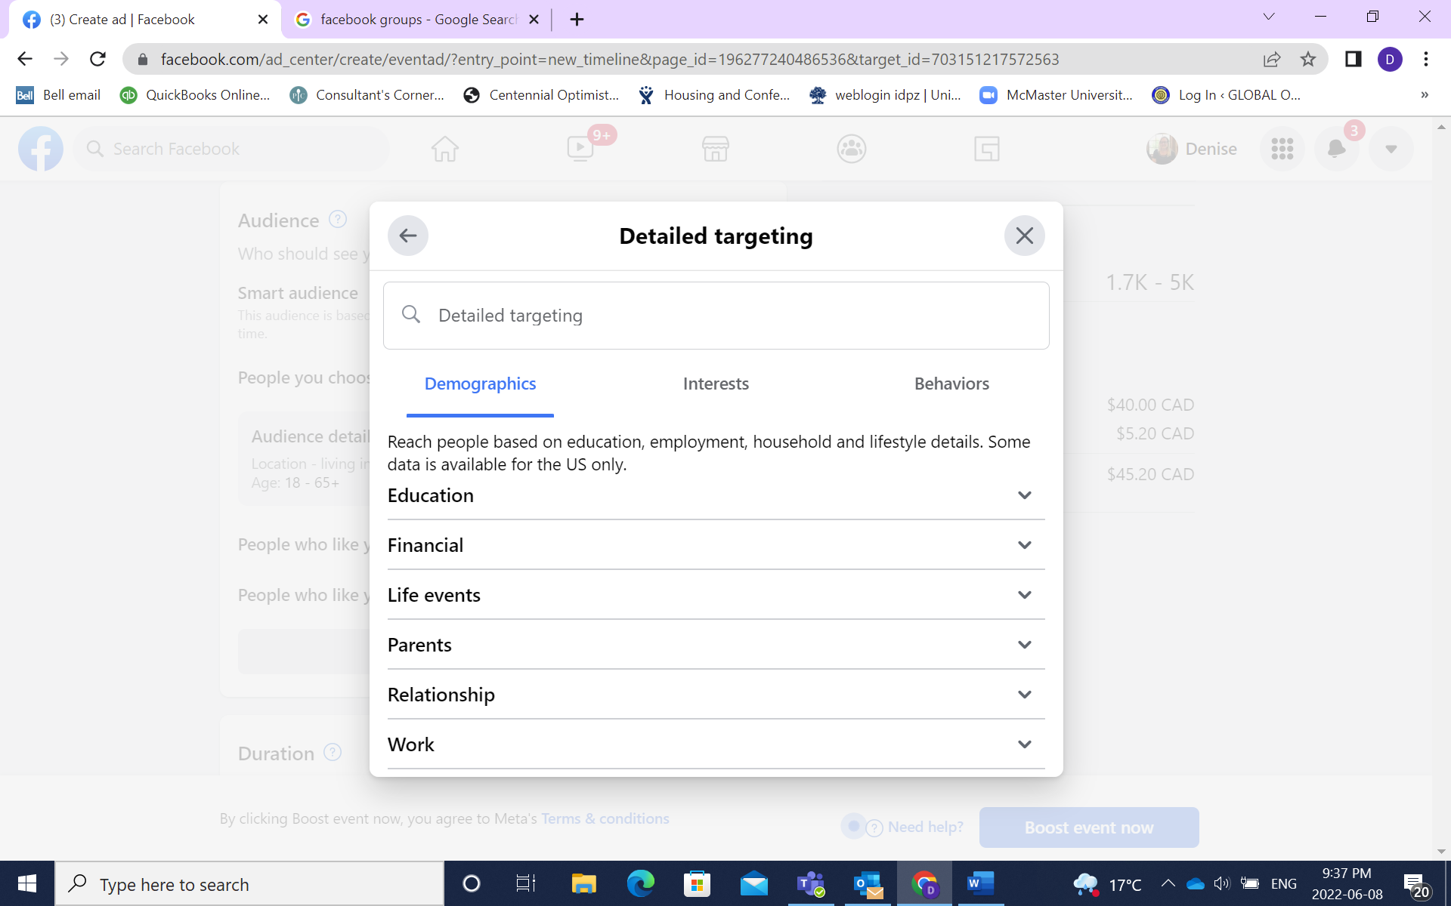
You can click through the various interests to select or you can just leave it general.
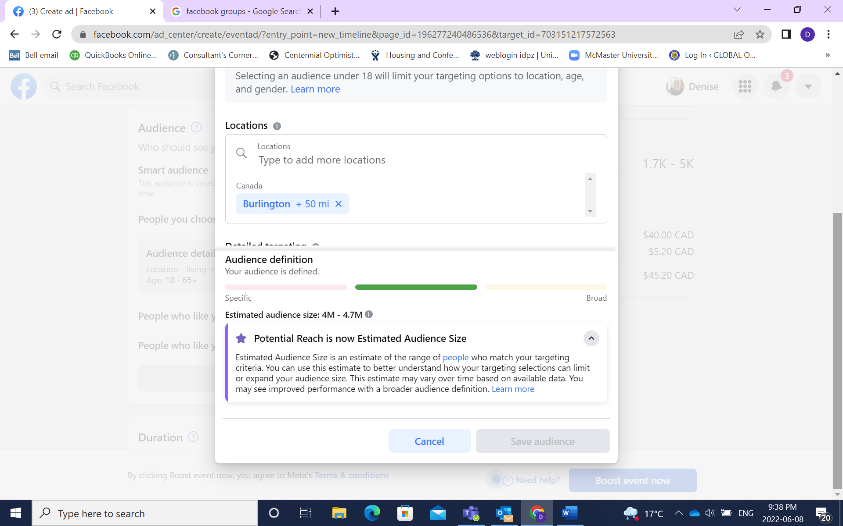
The Green Bar tells you have selected a good target audience and it tells you the potential reach of your ad
This is where you select how long you want the ad to run and what your budget is. You can set any amount you want. You will see how many people will be reached each day based on your budget. The ad will stop running when it reaches your budgeted amount. Make sure you set a budgeted amount or you will get charged more than you plan to spend. Then select Boost Now. Your ad will then go through a review process to make sure it meets Facebook policies. Once the ad is live you will then get notification.
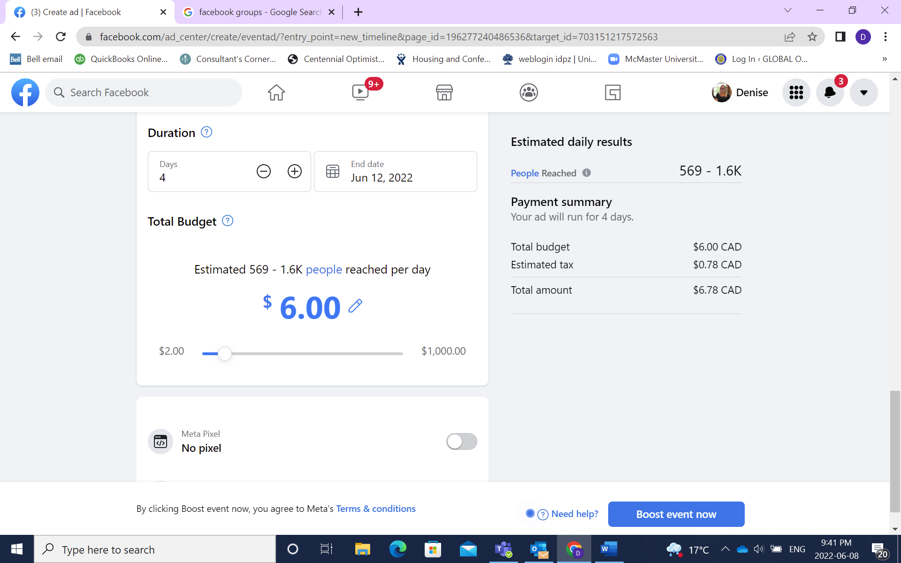
Once you ad is running to can look at how many people it is reaching and the impact the ad is having. At your Facebook page. Scroll down on the left hand side and select Ad Centre
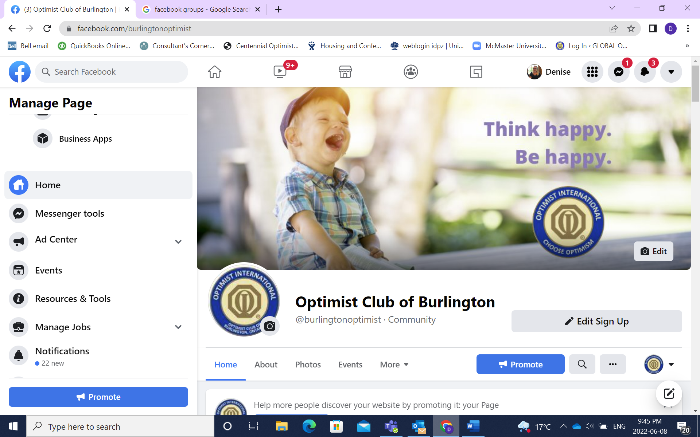
Scroll down to find the ad that you want to look at the information. Click on View Results
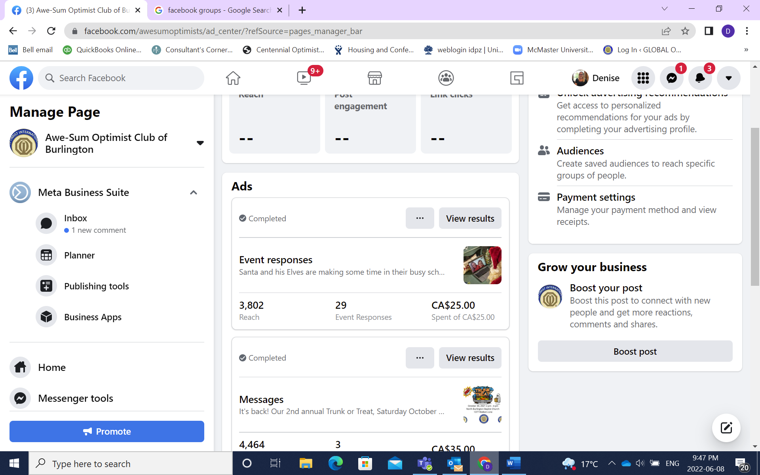
Here is some information that will allow you to assess the effectiveness of the ad
