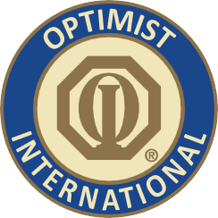

PRINT ON CLUB LETTERHEAD OR TYPE IN CLUB NAME
CONTACT
CLUB CONTACT CONTACT'S NUMBER

FOR IMMEDIATE RELEASE DATE

International Service Organization Looks to Help Local Youth
One of the world’s largest civic service organizations has chosen NAME OF COMMUNITY as its next venue for helping youth. Volunteer members of Optimist International will be spending the next few weeks in COMMUNITY, with the goal of organizing a new Optimist Club.
“We are excited about helping the children of COMMUNITY,” Club President PRESIDENT'S NAME said, who is organizing the local expansion effort. “We are looking for some other like-minded individuals who would like to help us improve the lives of children in our community.”

(Enter local information about the building project, for example: The Optimist Club of WACO has decided to start an after-school enrichment program. Local students will meet twice a week to get help on homework from mentors, and to have fun through arts and crafts and other recreational activities, Jane Doe, an Optimist volunteer from WACO said. )

Optimist International is one of the world’s largest service club organizations with over 80,000 adult and youth members in almost 3,000 clubs in the United States, Canada, the Caribbean and Mexico and throughout the world. The Optimist Oratorical Contest is one of the organization’s most popular programs, with more than 2,000 clubs participating annually. Carrying the Mission Statement by providing hope and positive vision, Optimists bring out the best in youth, our communities and ourselves. Optimists conduct positive service projects that reach more than six million young people each year. To learn more about Optimist International, please call (314) 371-6000 or visit the organization’s website at www.optimist.org.

###

